CMPE 100 Lab Report 4

Leonid Shuster

Lab Section 1C

5/13/19

**Description:**

In this lab we were tasked with creating a 16-bit counter where the top two digits were decimal, while the lower two were hexadecimal. The counter could count up, down, or quickly up, and displayed its value on all of the 7-segment LED displays on the Basys3 board. The counter could also load a 16-bit number determined by the position of the 16 switches on the board. In this lab, we learned about how to make our designs synchronous with the system clock and how to implement sequential logic into our designs.

**Part One: Counter Design**

In the first part of the lab, we learned how to use sequential logic in our designs by making use of flip-flops for our 16-bit counter. The counter consisted of four individual counters, two of which counted to F while the other two counted to 9. Each counter also kept track of when they were at their minimum and maximum values. Flip-flops were used so that the counter was synced with the system clock, and if the clock enable were high, the counter would load a new value, but it were low, the counter would keep its value and either count up or down.

For the counter that went up to F, in order to output the correct incrementation or decrementation when the clock enable was low, I created a truth table that accounted for every possible input and its correct output, created kmaps from the table, and derived logical expressions for the output. The code for the counter is the following:

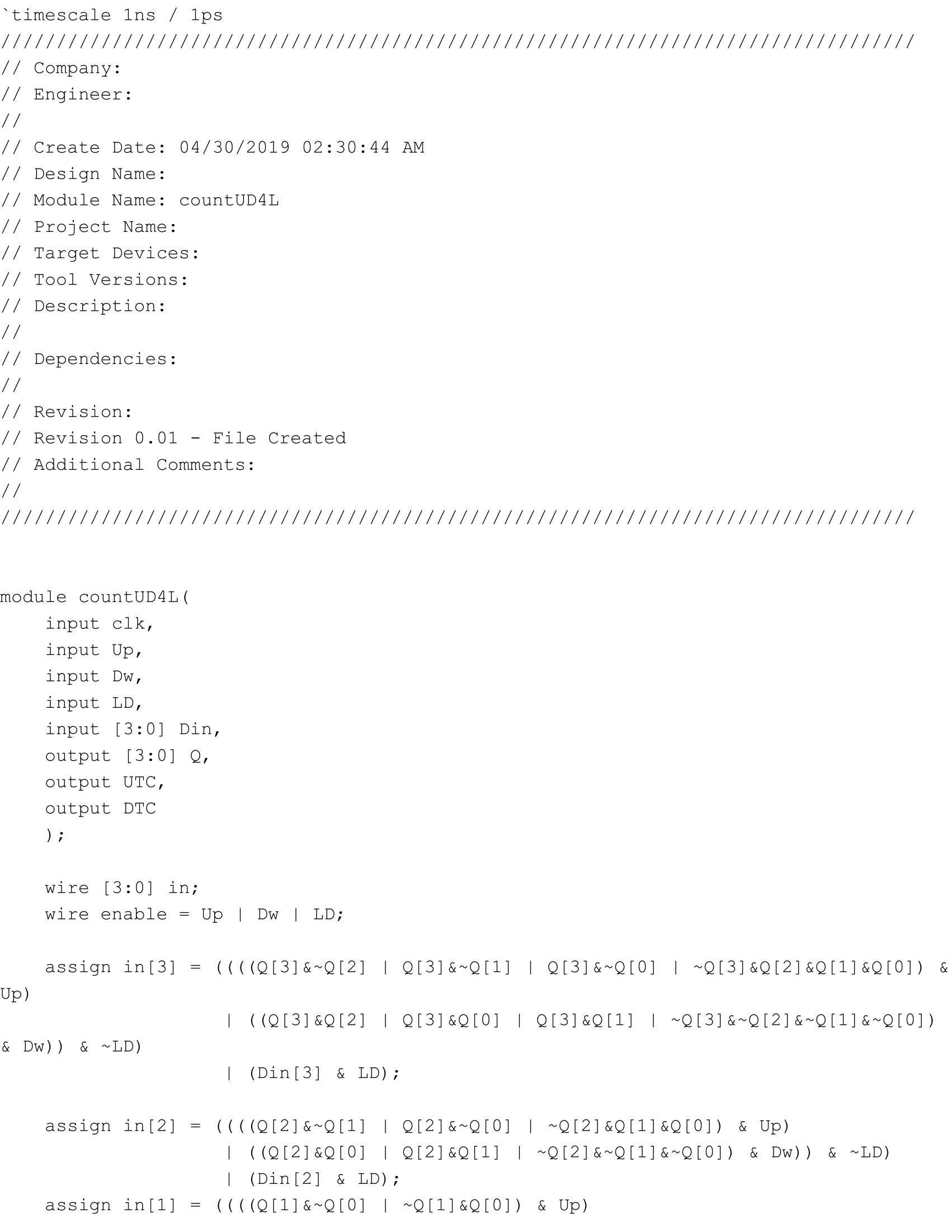

countUD4L.v part 1

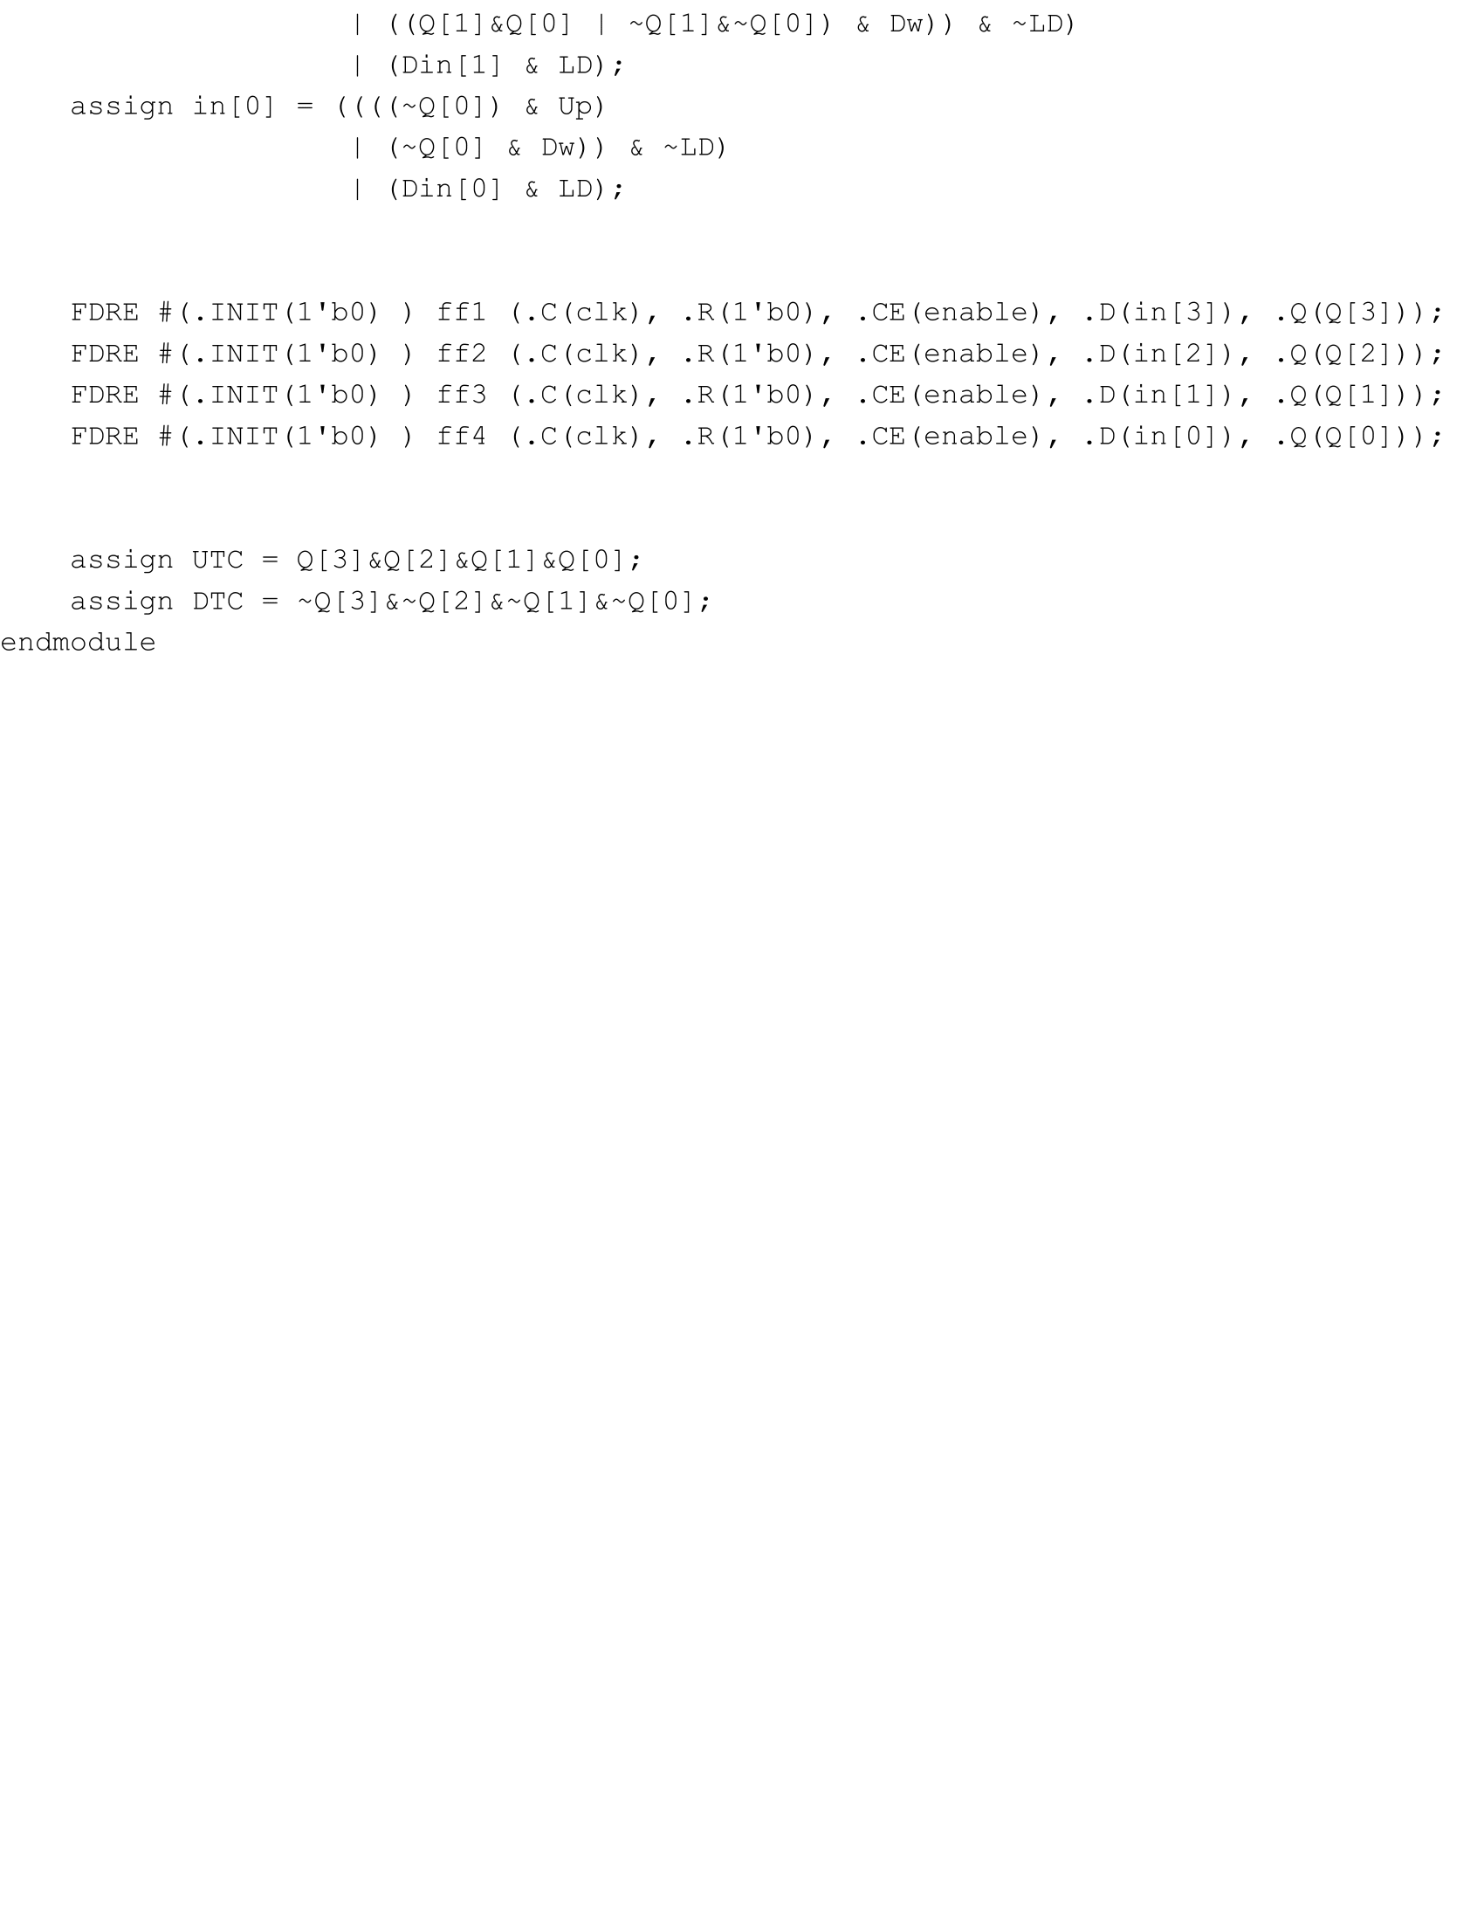

countUD4L.v part 2

The same was done for the counter that went up to 9, but don’t cares were used in the case when the current value in the counter exceeded 9. The code for it is the following:

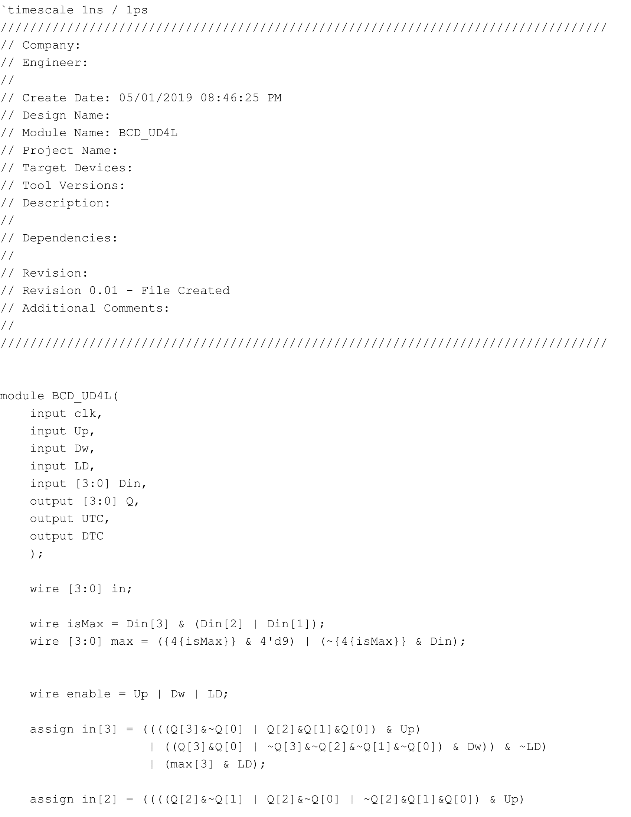

BCD_UD4L.v part 1

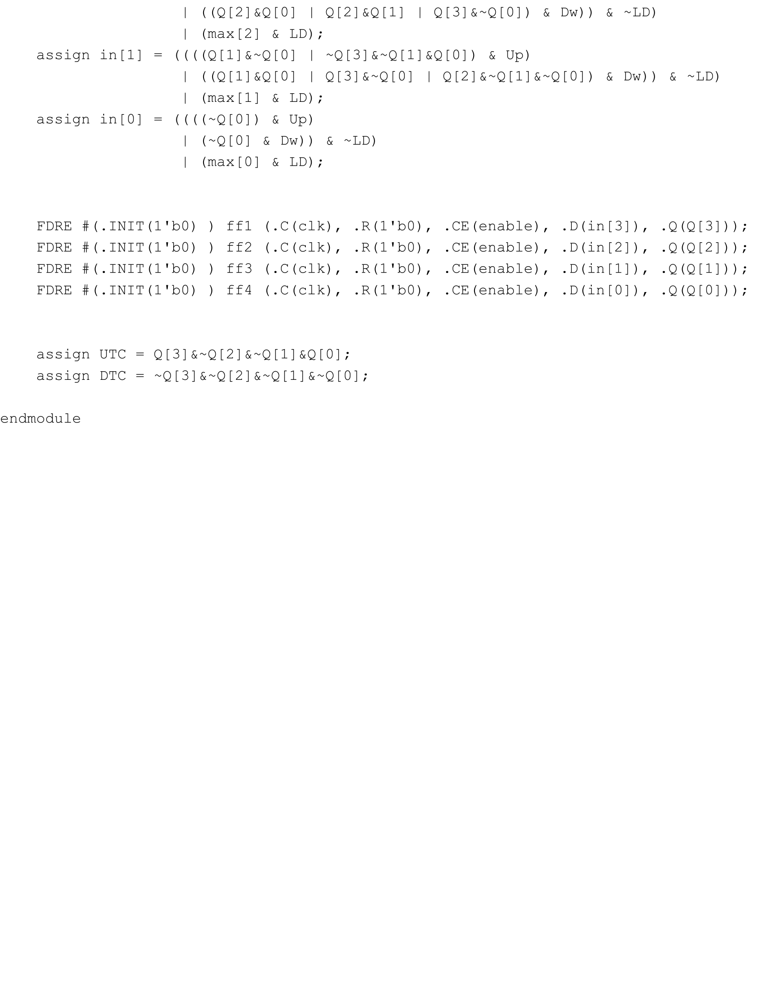

BCD_UD4L.v part 2

After creating the two possible counters, I created the 16-bit counter by putting together two counters that counted up to F, and two counters that counted up to 9. Each successive counter only counted up or down when the previous counter was at its max. The 16-bit counter also kept track of when it was at its minimum or maximum, either 0000 or 99FF. The code for it is the following:

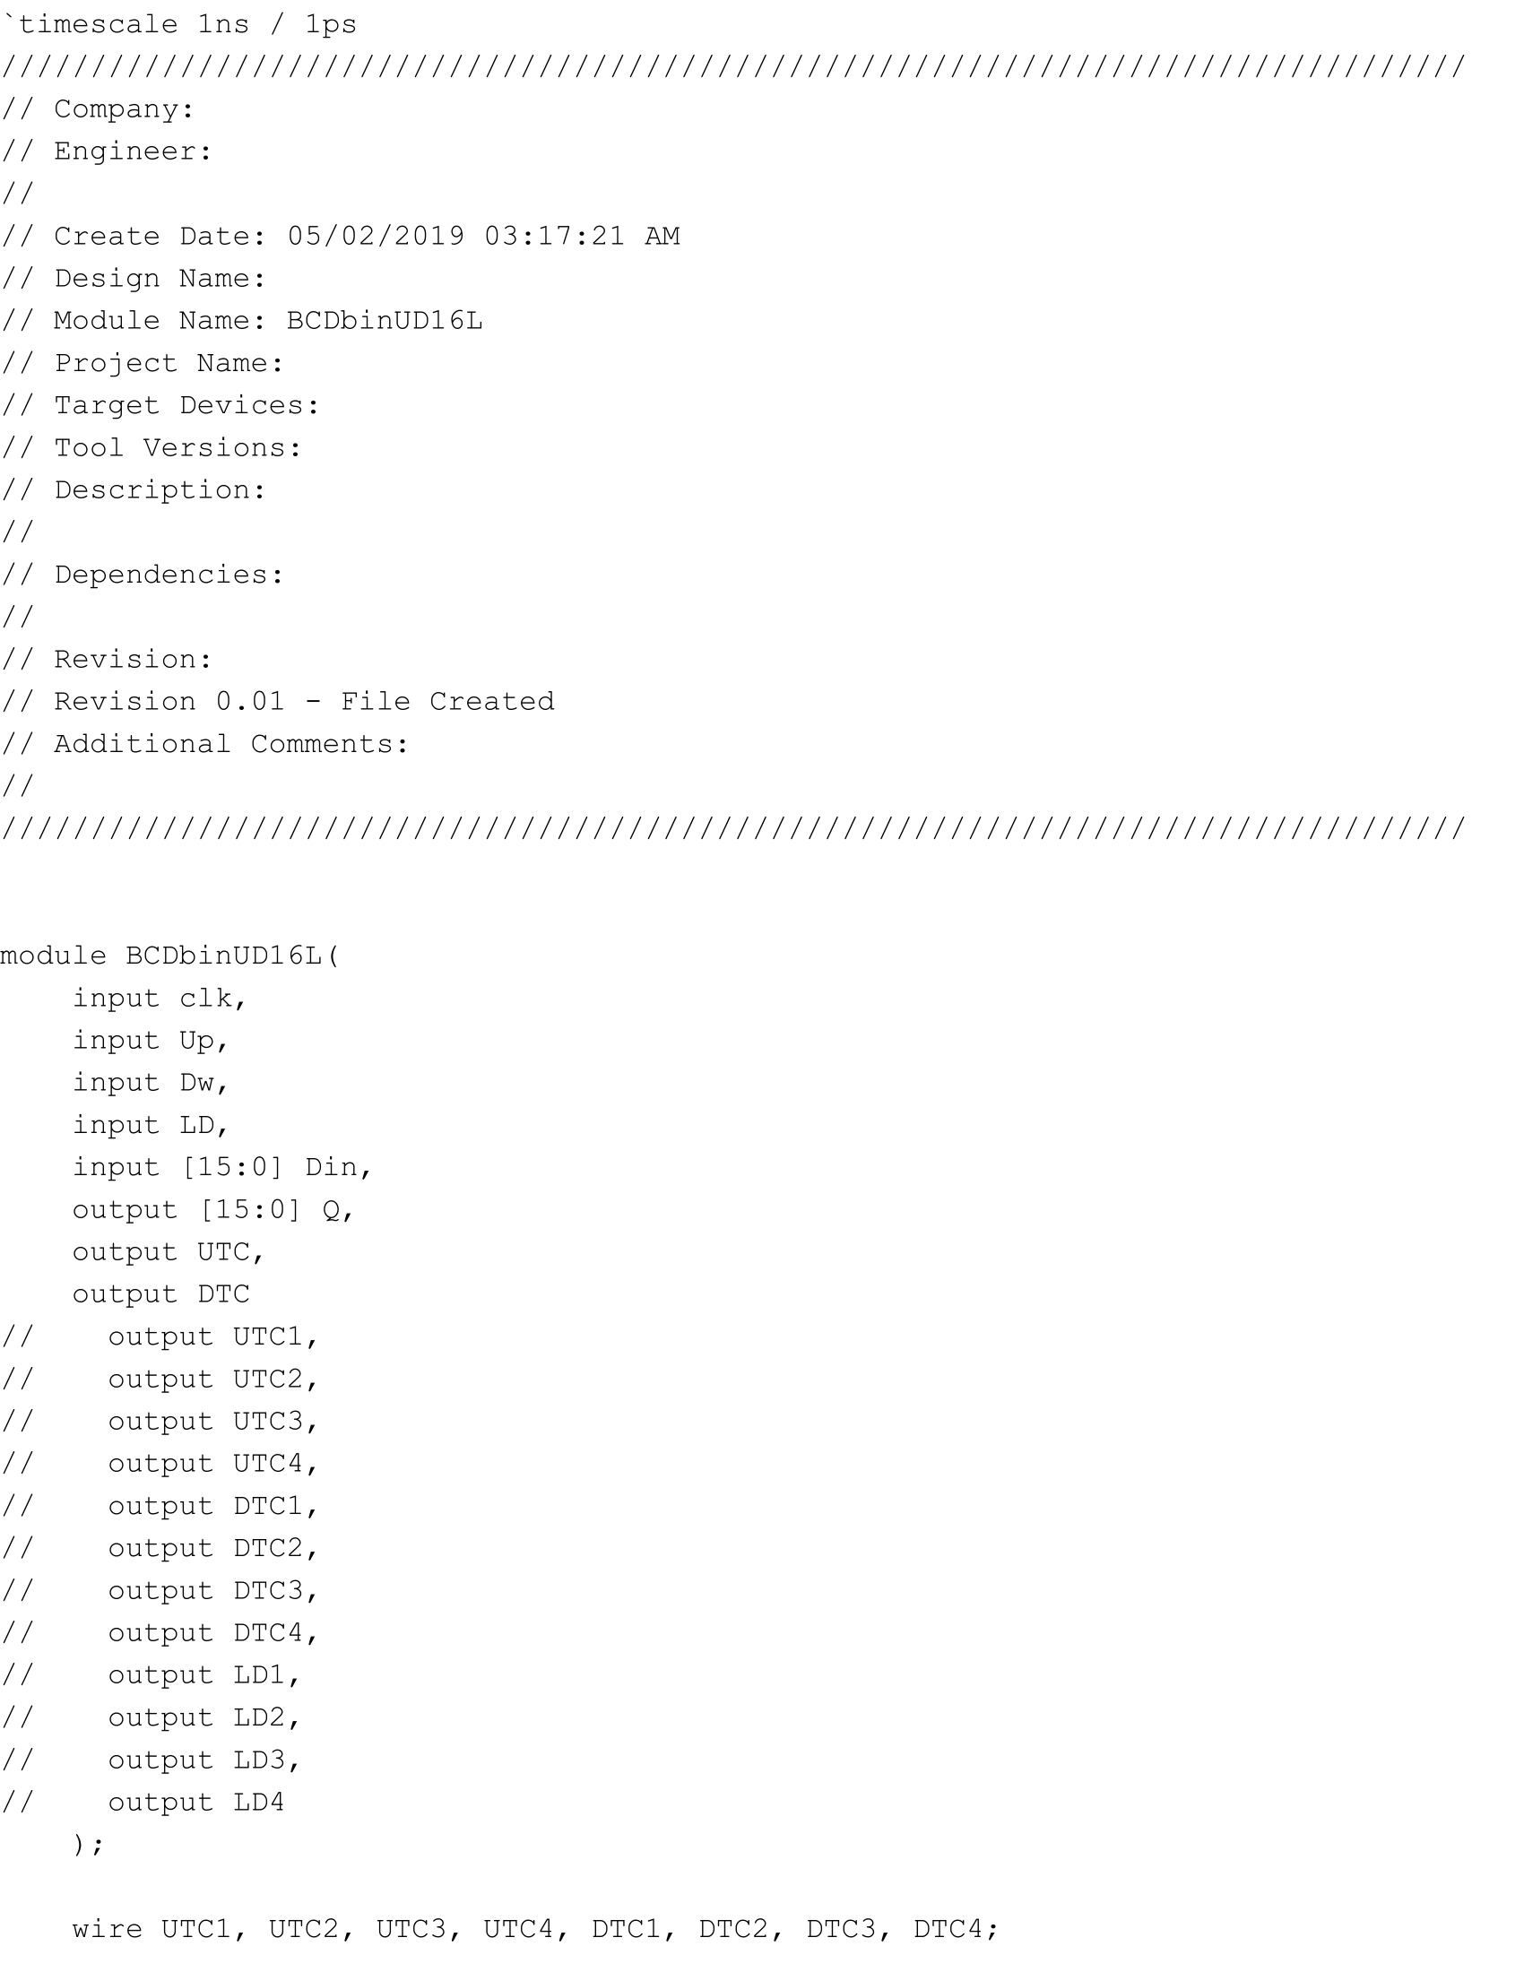

BCDbinUD16L.v part 1

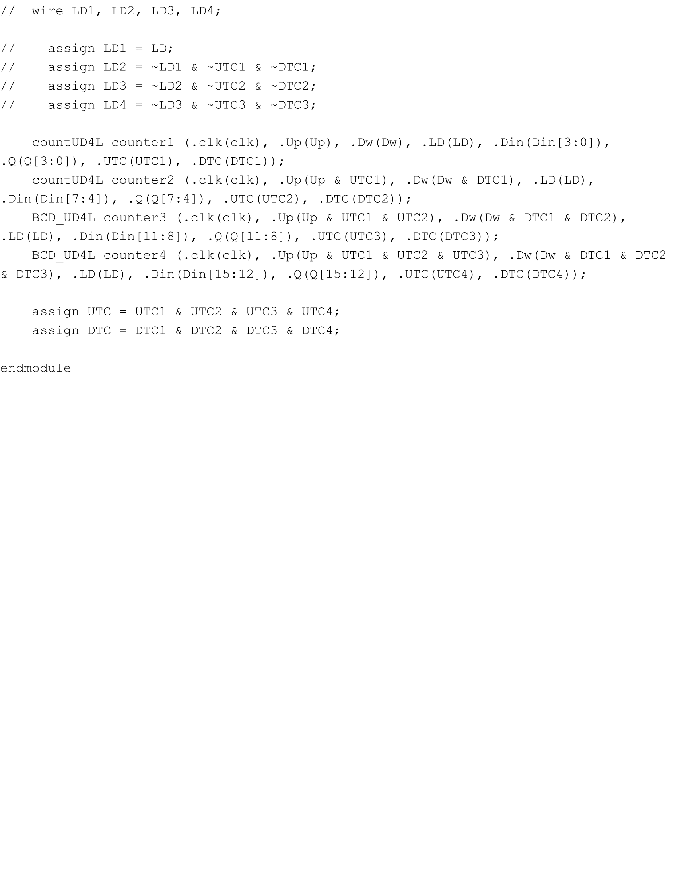

BCDbinUD16L.v part 2

**Part Two: Selector**

The next part of the lab was to create a selector that would choose 4 bits out of a 16-bit vector depending on a selector in order to decide which 4 bits to display onto the Basys3 board. This was simply done by creating a mux that choose 4 bits depending on the selector. The code for it is the following:

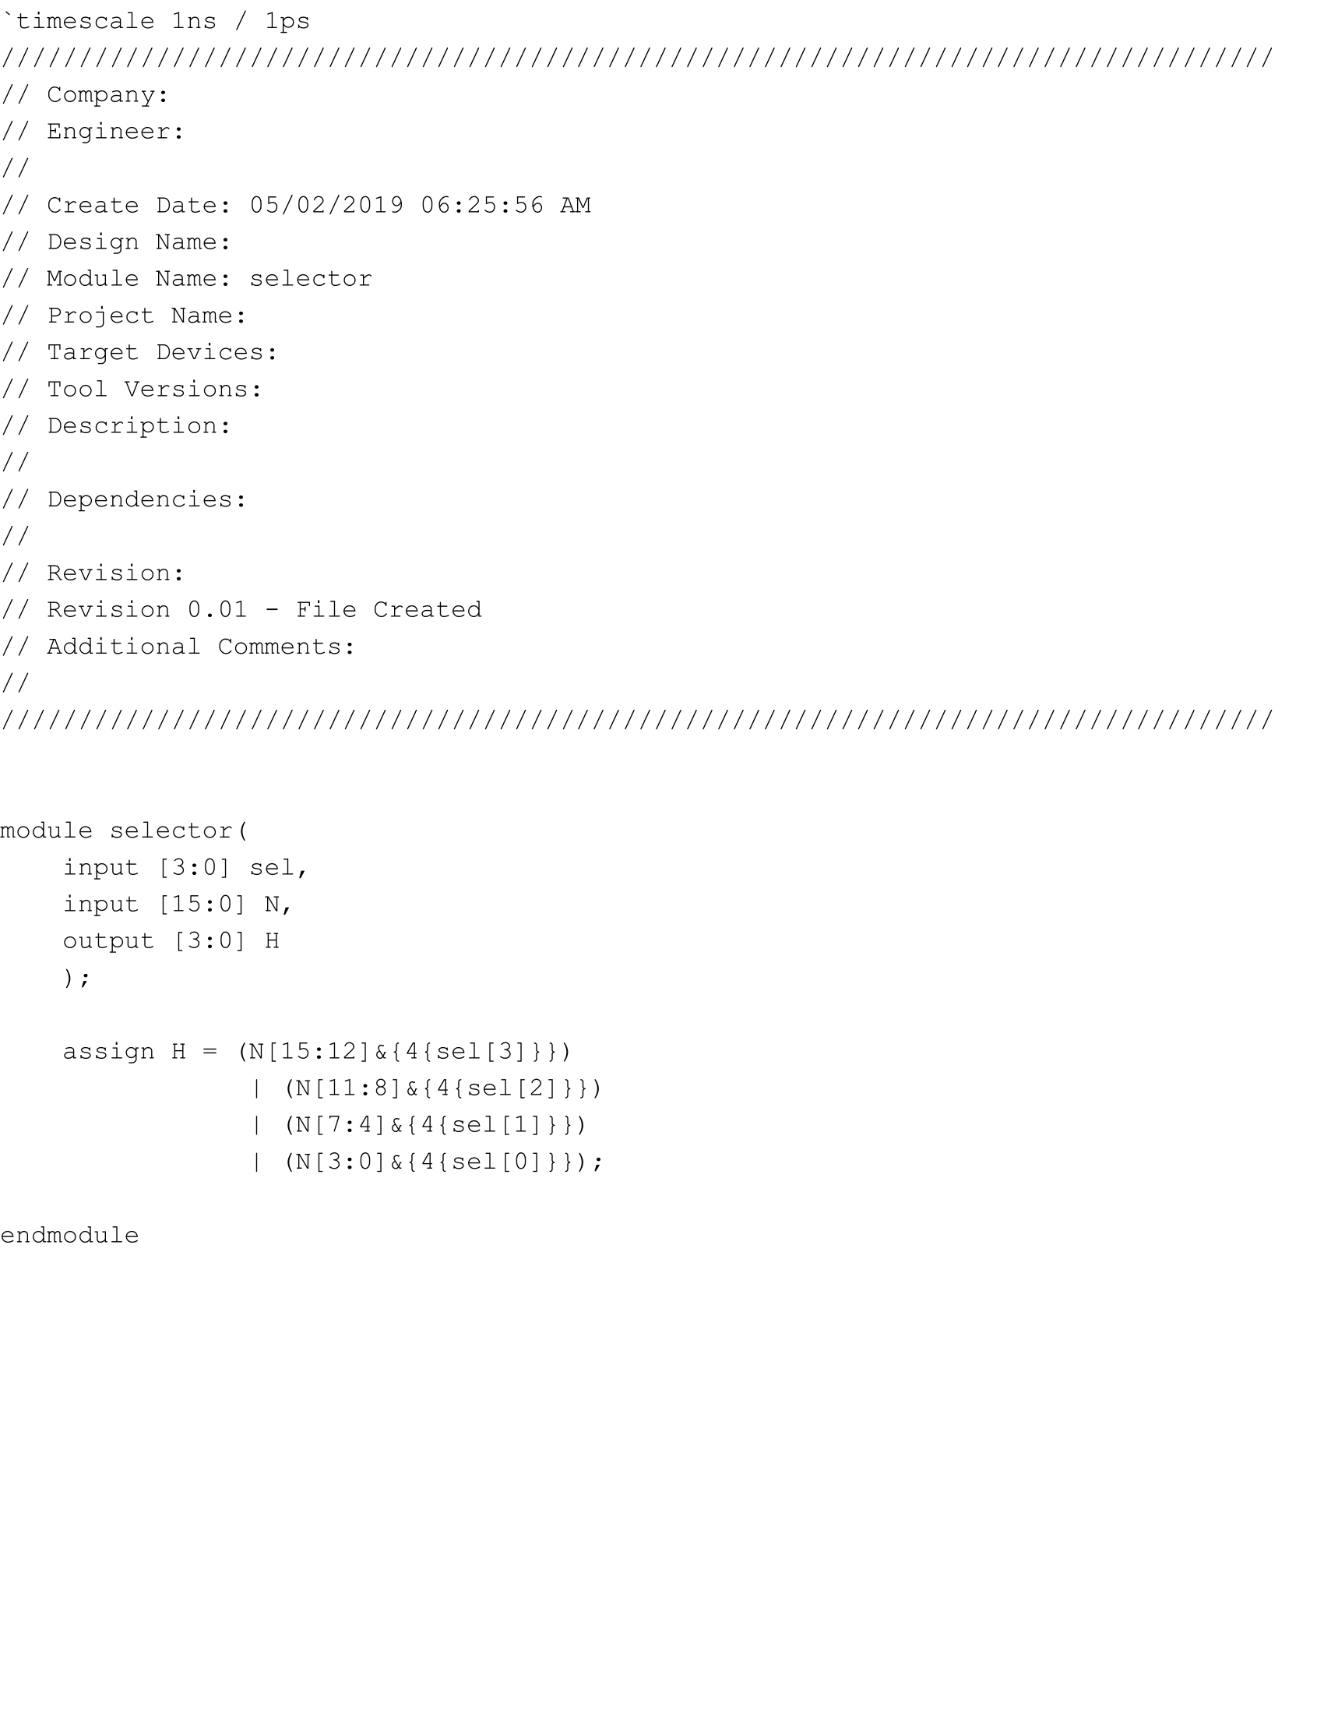

selector.v

**Part Three: Ring Counter**

In this part of the lab, we needed to created a ring counter that repeatedly shifted a 1 around that could then be used as the selector for the previous part. This was done by using four flip-flops, with one of them initialized to 1, and continuously shifting the 1 from bit to bit. The clock enable was also set to the digsel provided by the professor. The code for it is the following:

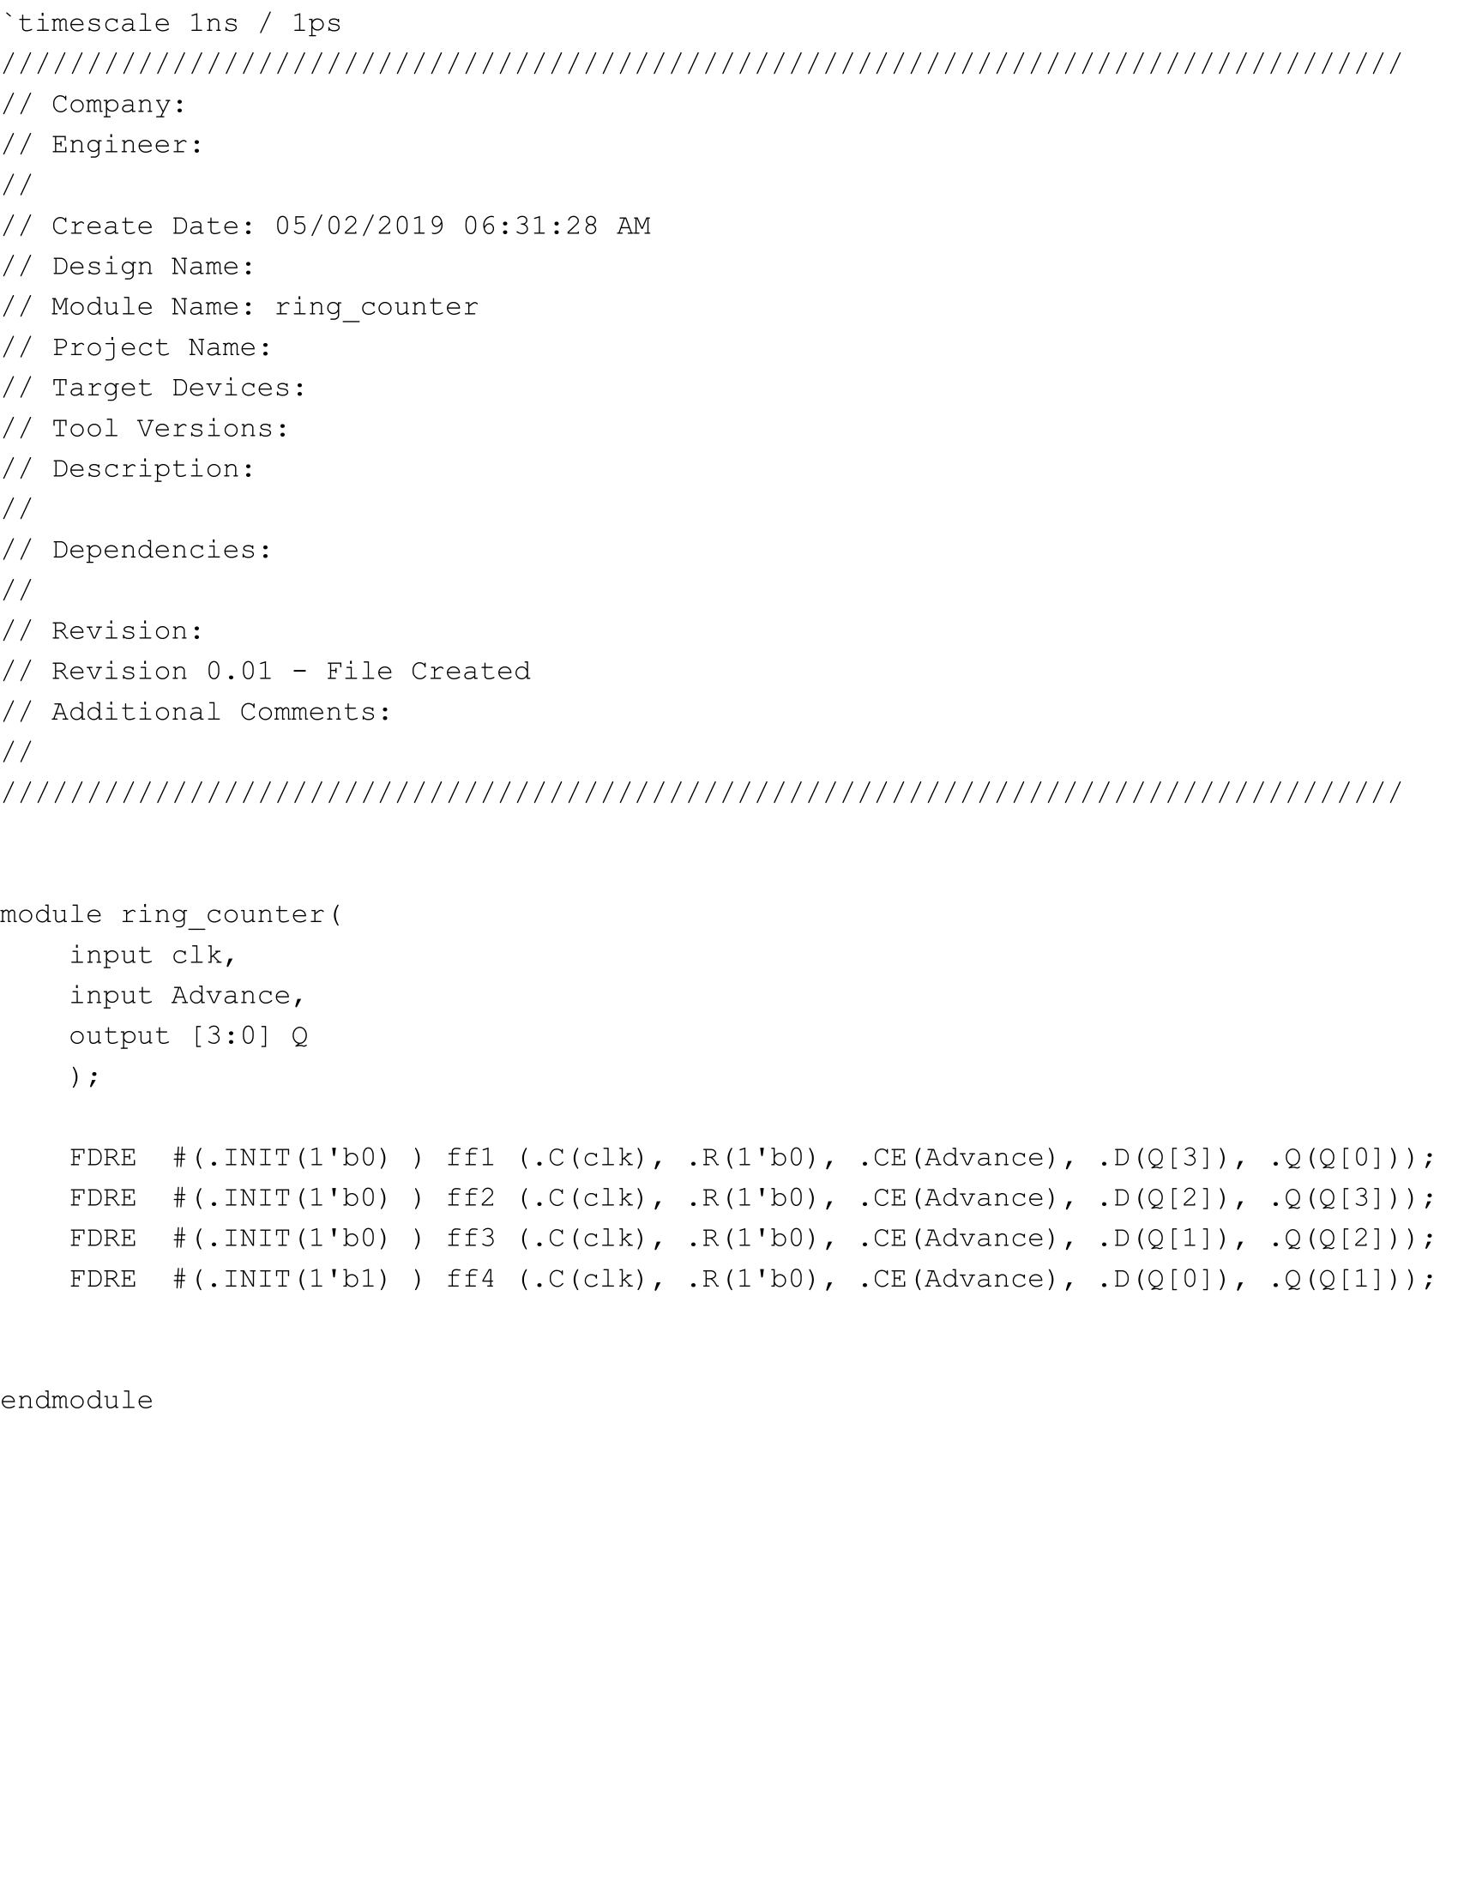

ring_counter.v

**Part Four: Edge Detector**

In the next part of the lab, we needed to create edge detectors for the buttons we were going to press on the Basys3 board in order to register one press. To do so, I used two flip-flops that synced with the system clock and kept track of two past inputs, and outputted a high value if it detected a 0 followed by a 1 representing the press of a button. The code for it is the following:

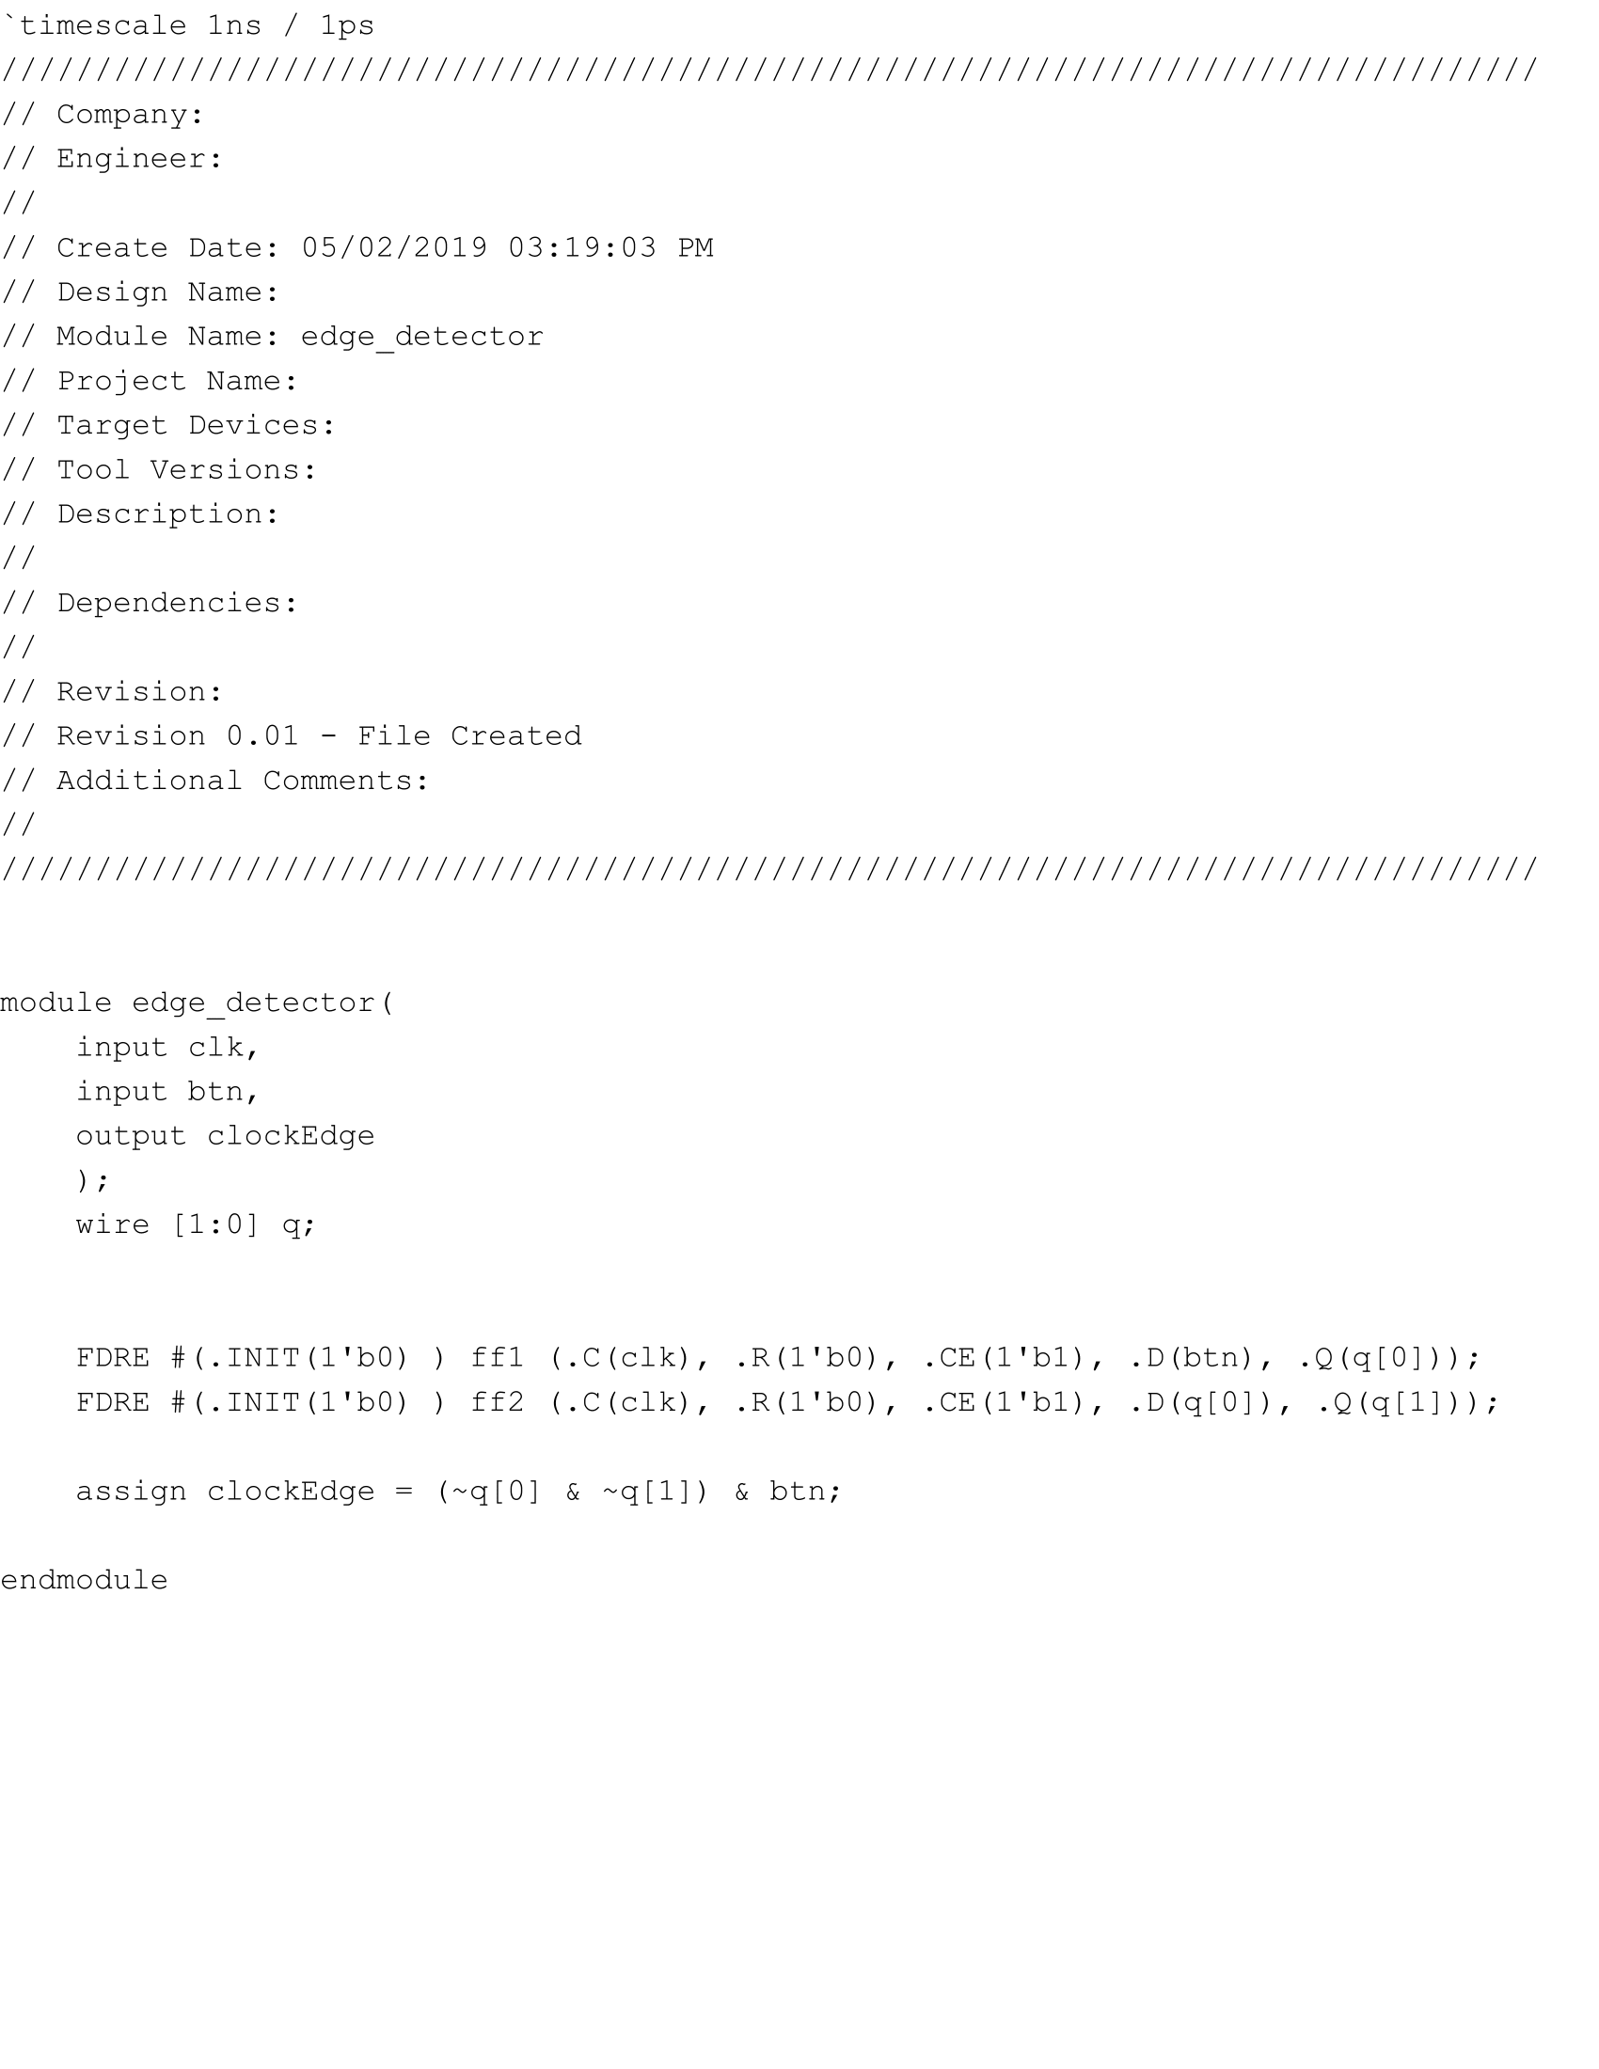

edge_detector.v

**Part Five: Top Level Module**

In the next part of the lab, we put everything together into a single module so that every single press of btnU incremented the counter, while every press of btnD decremented the counter. By pressing btnC, the counter quickly counted up until 99FC, which was simply done by registering the press of the button without detecting an edge and capping the counter at 99FC when holding down btnC. In addition, btnL was routed as the clock enable for the counter’s flip-flops so that when btnL was pressed, the value of the 16 switches on the board would be loaded into the counter. Finally, the ring counter kept shifting 1 over and over again, and was used as the selector for the mux that chose 4 bits of the 16 bit counter to display at a time. The minimum and maximum instances of the counter were also displayed in the form of a decimal point on either the left or right side of the 7-segment display. The following shows the schematic and code for the module:

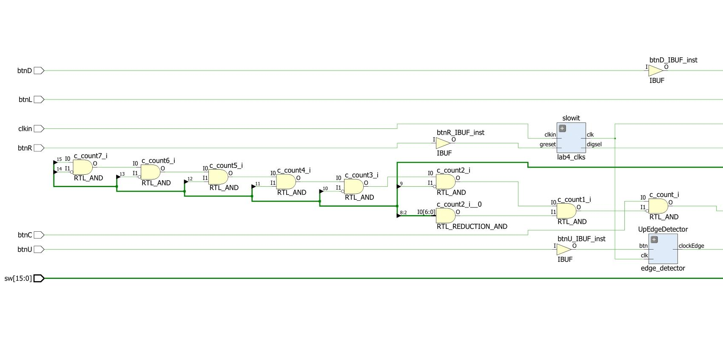

top_mod schematic part 1

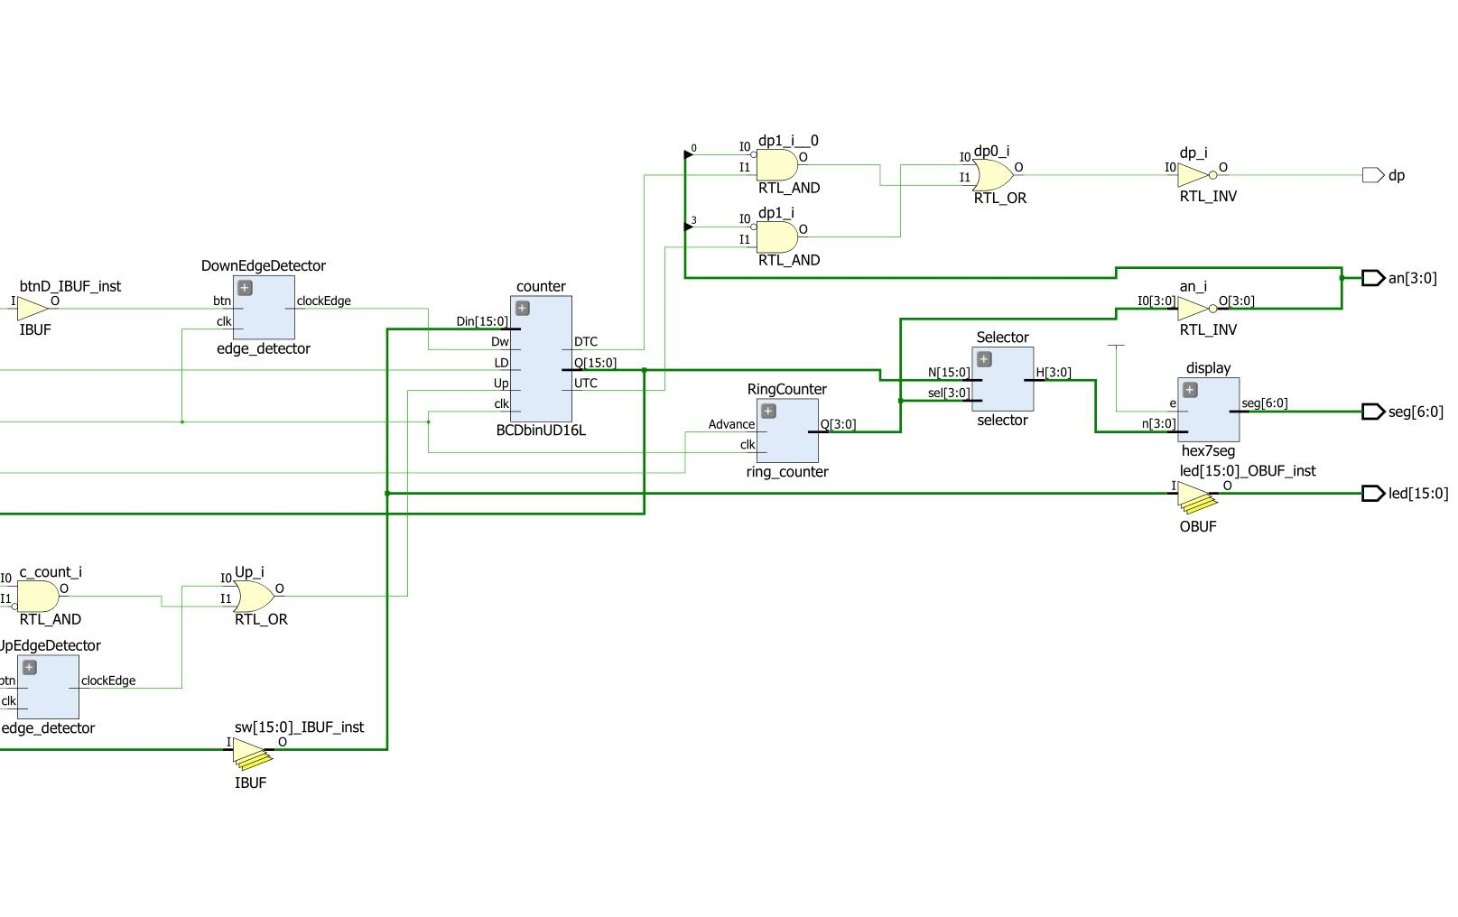

top_mod schematic part 2

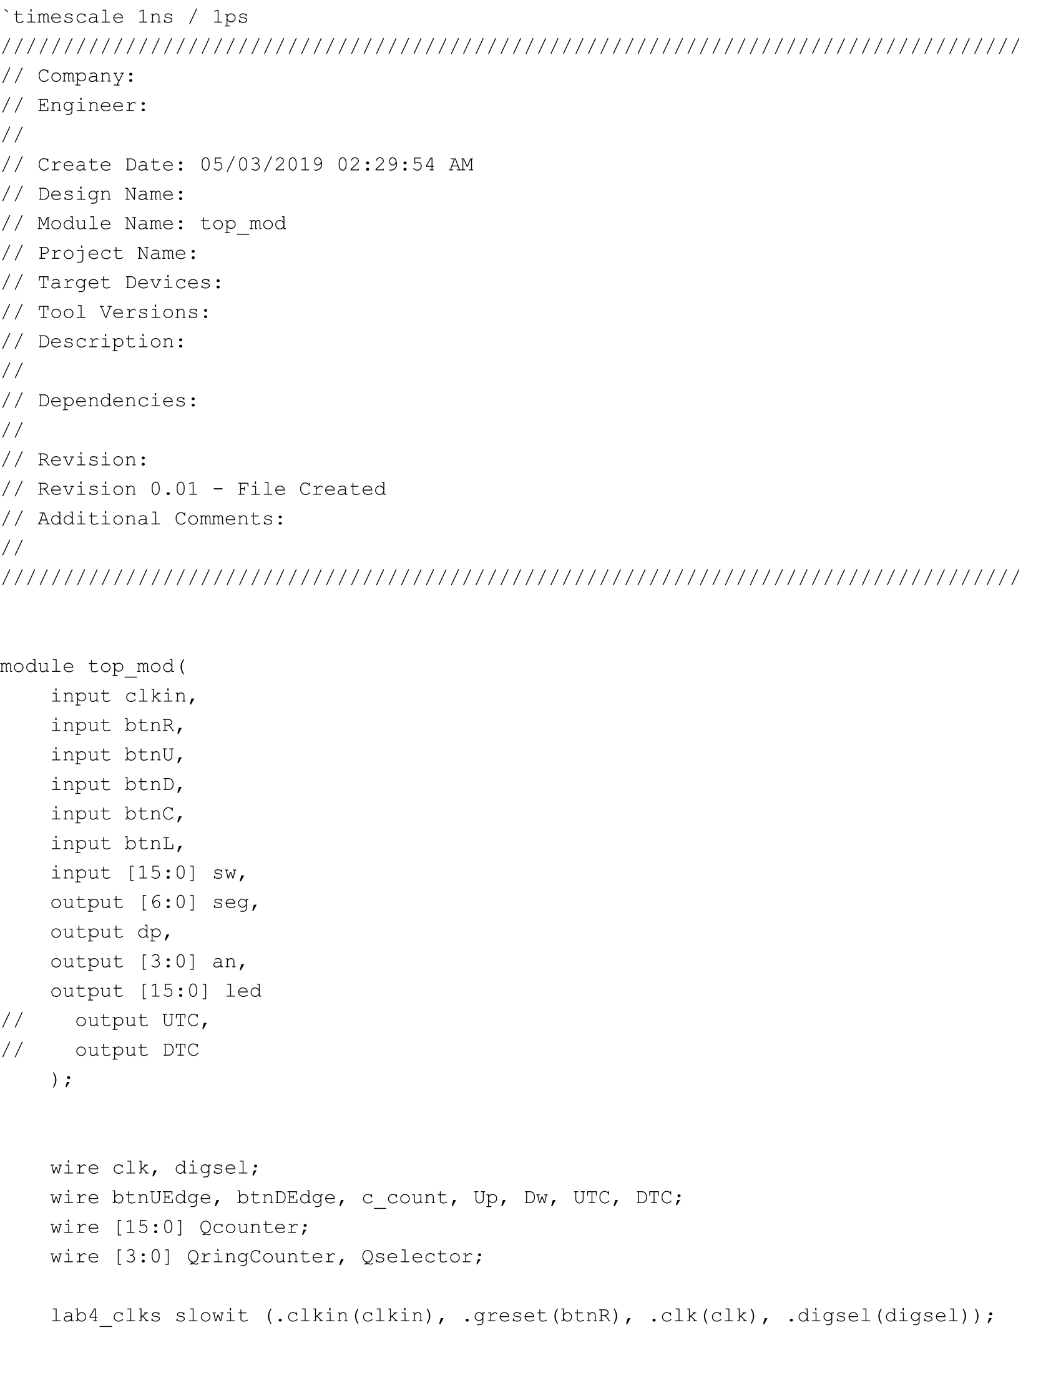

top_mod.v part 1

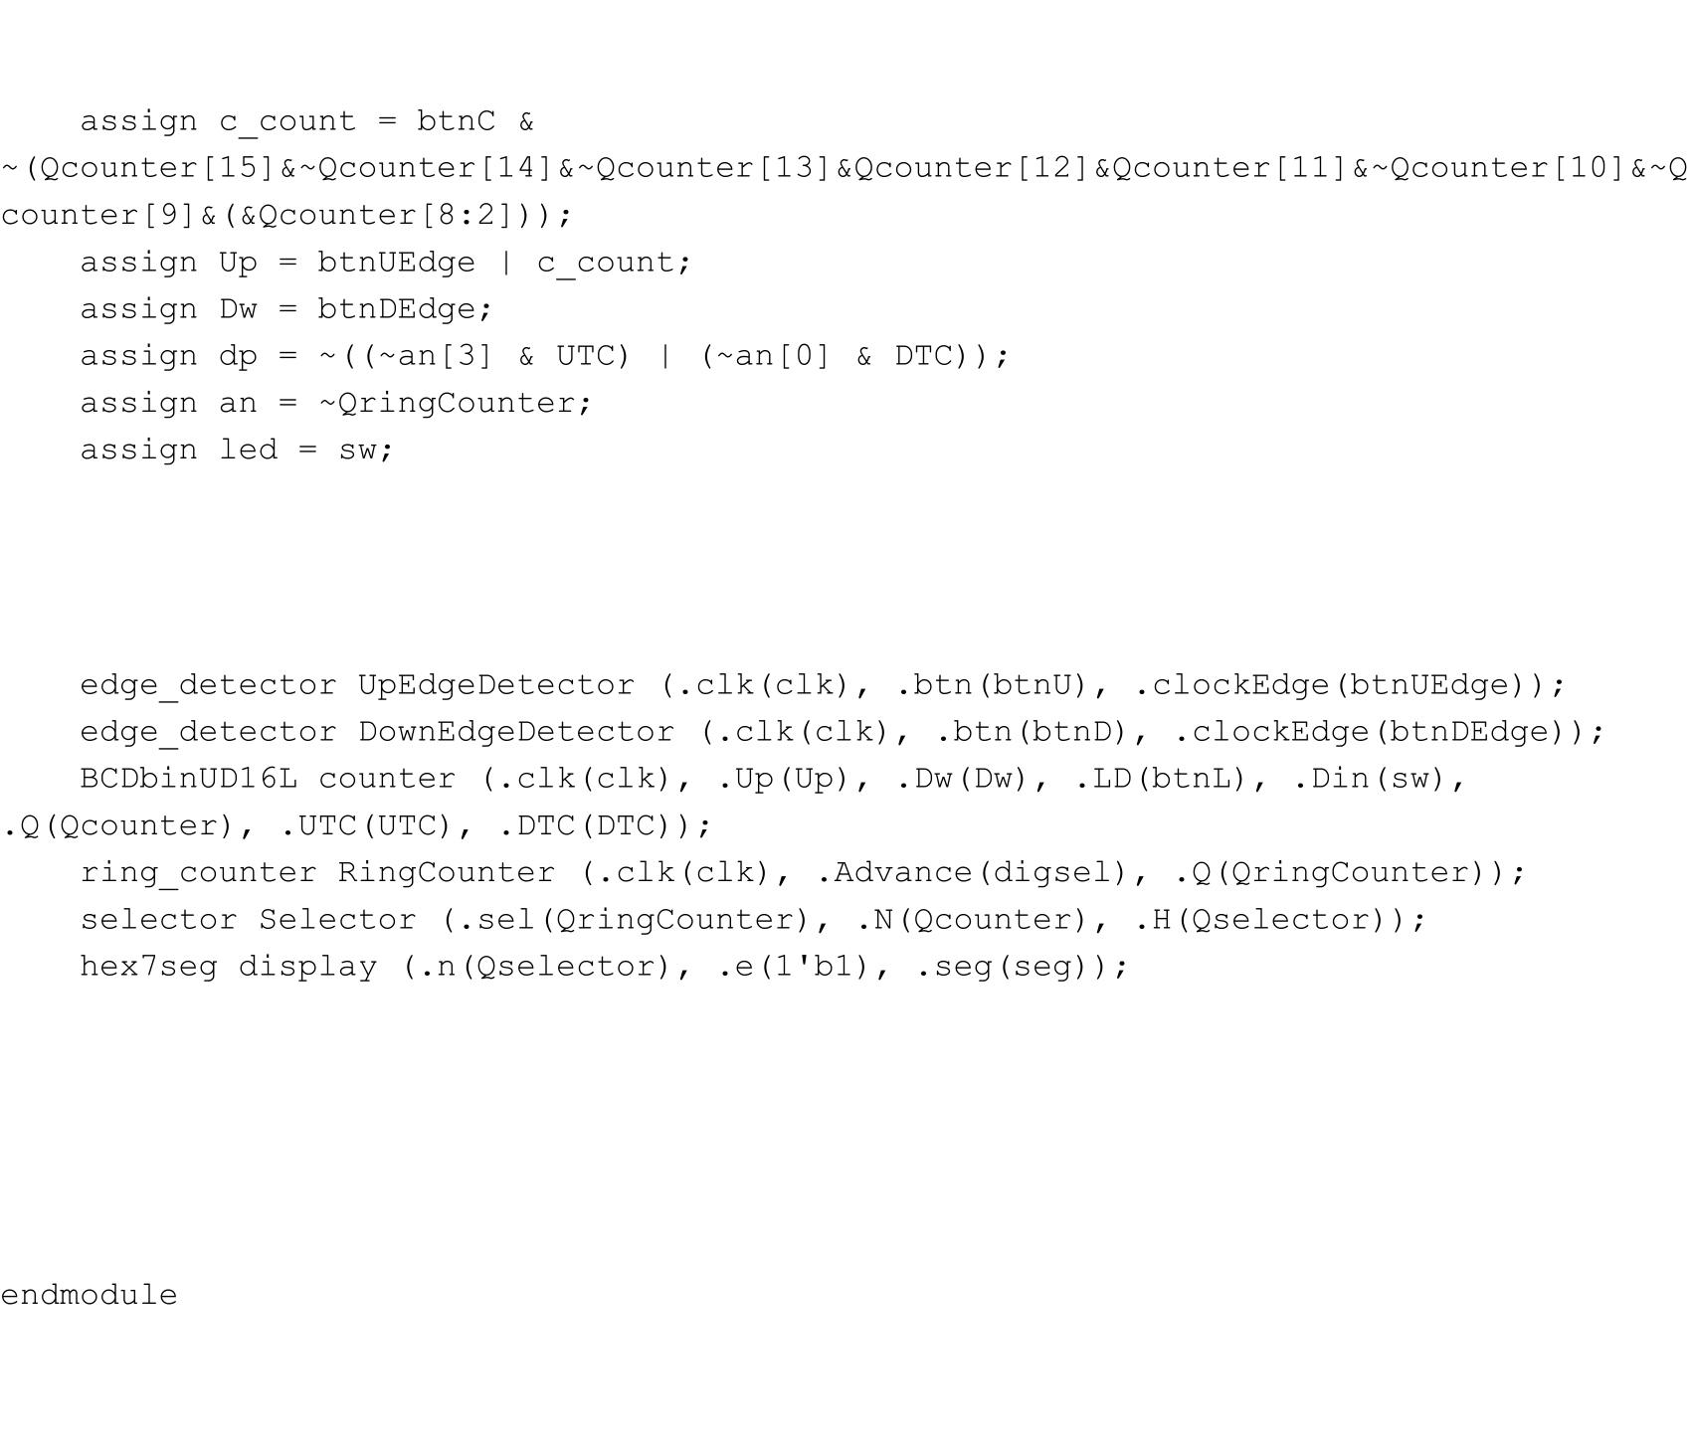

top_mod.v part 2

After mapping the output of the top level module to the constraints file, I tested out pressing down btnU, btnD, btnC and btnL and verified that the counter was indeed counting up or down or loading values from the switches and displaying its results on the Basys3 board. When I held down btnR, only one of the 7-segment displays showed something, a 0, which I believe is because that was the exact flip-flop that was always being initialized with 1 and thus was always outputting something to that exact bit of the an vector. When I used fastclk instead of clk, I saw that all the lights on the 7-segment displays were weaker and did not show the correct results, except for the same flip-flop that was initialized with 1.

**Part Five: Using the Simulator**

Finally, I simulated the results of my top level module with the test bench provided by the professor and verified that my counter was reaching its minimum and maximum values correctly. The results were the following:

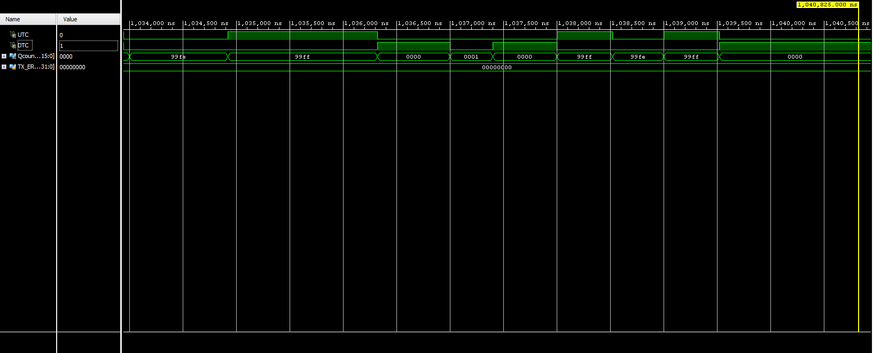

Waveform Viewer

**Conclusion:**

In conclusion, we successfully built a functioning 16-bit counter that could count up, down, quickly up or load a value from switches, and display its value onto the 7-segment displays. We learned how to implement flip-flops and sequential logic in our designs in order to produce outputs that depend not only on the present value, but previous ones too. If I were doing this lab again, I would make better use of the simulator by testing my code as soon as I write it instead of testing it after creating multiple files with code that could be wrong.

**Appendix**



countUD4L.v part 1



countUD4L.v part 2



BCD_UD4L.v part 1



BCD_UD4L.v part 2



BCDbinUD16L.v part 1



BCDbinUD16L.v part 2



selector.v



ring_counter.v

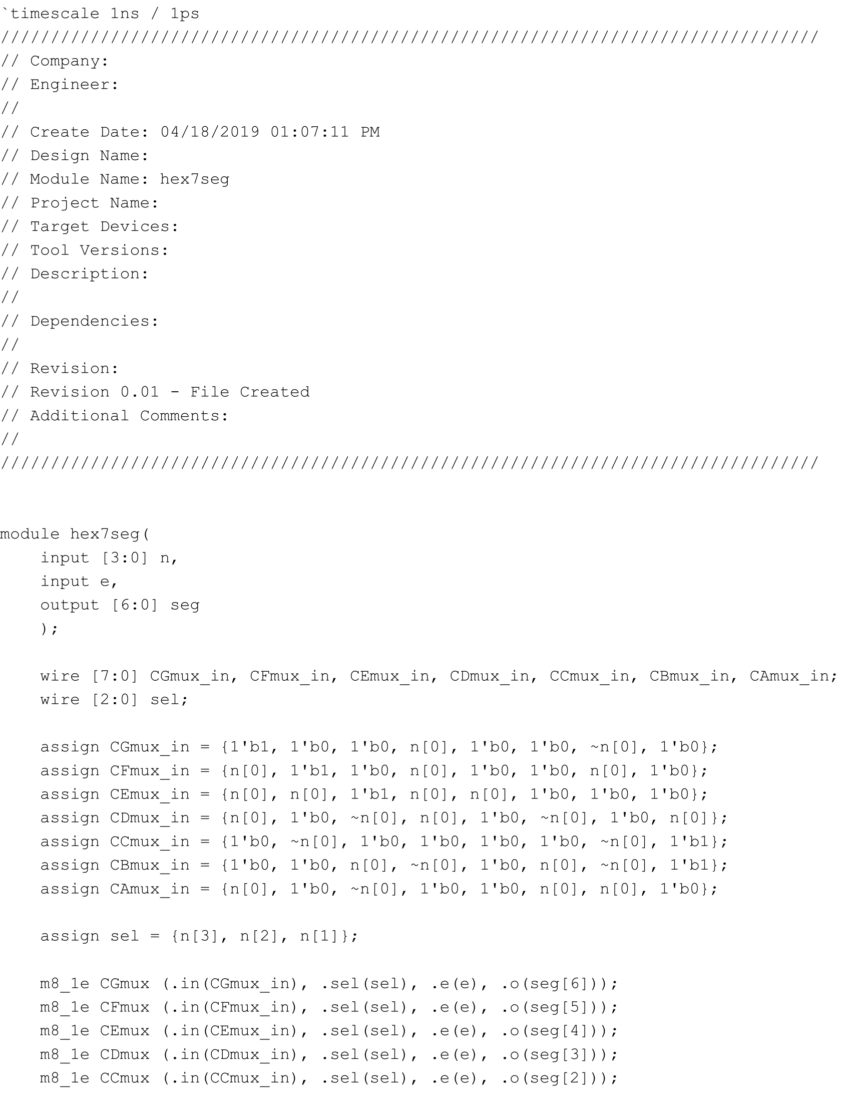

hex7seg.v part 1

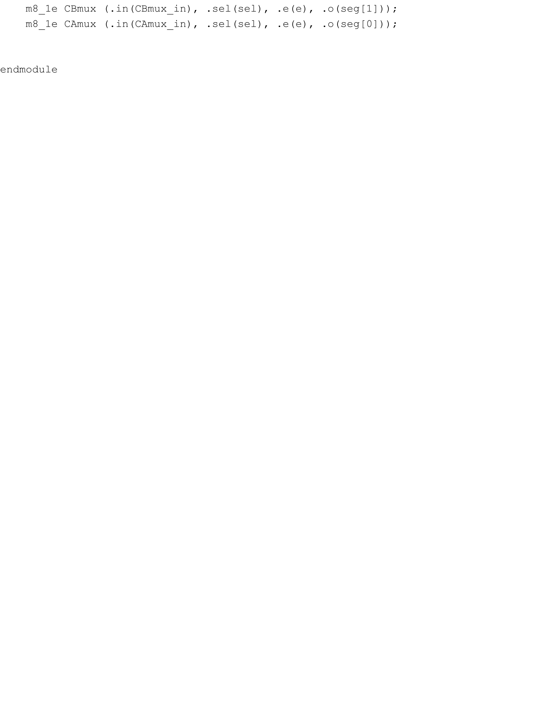

hex7seg.v part 2



edge_detector.v

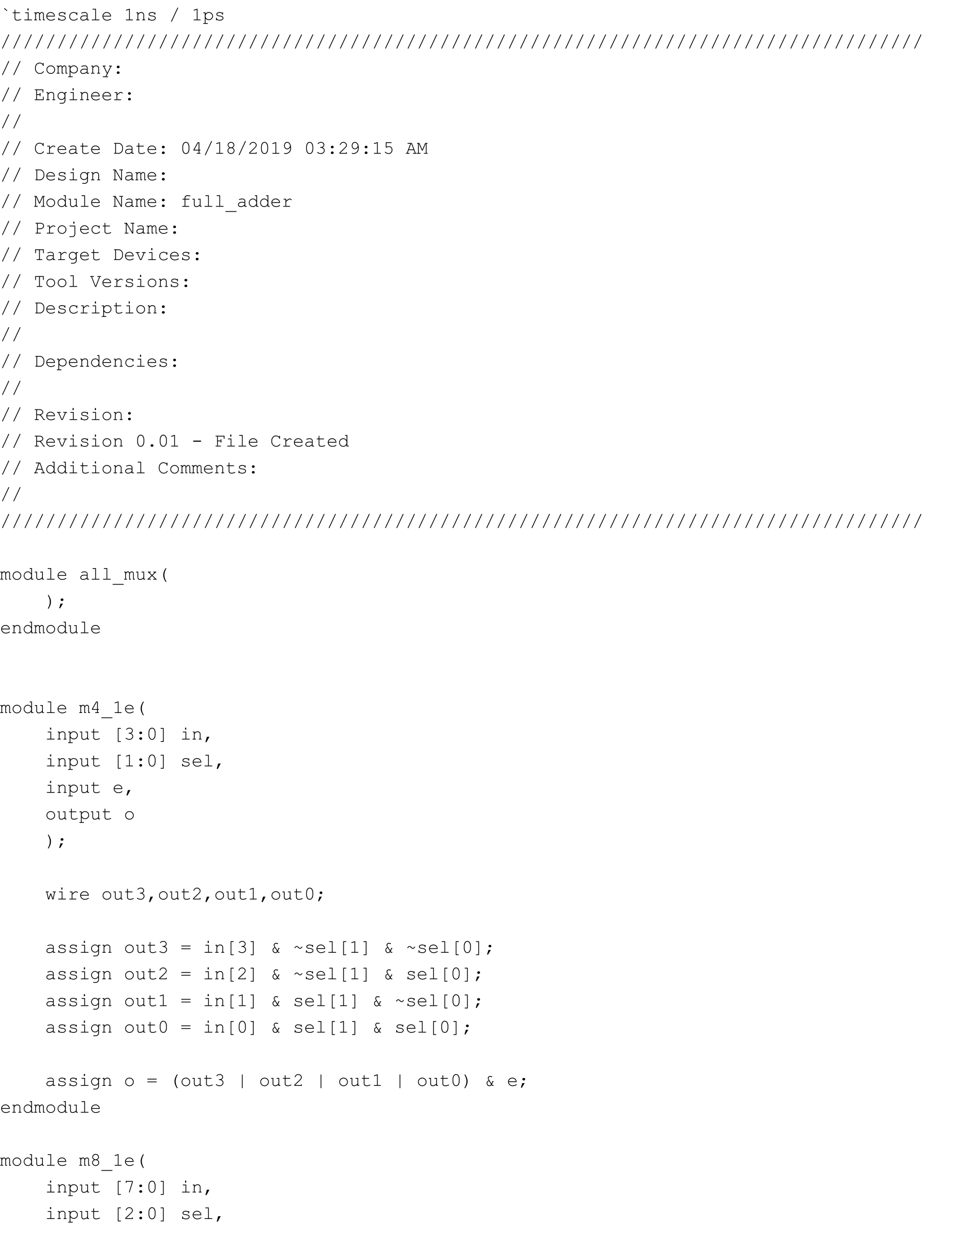

all_mux.v part 1

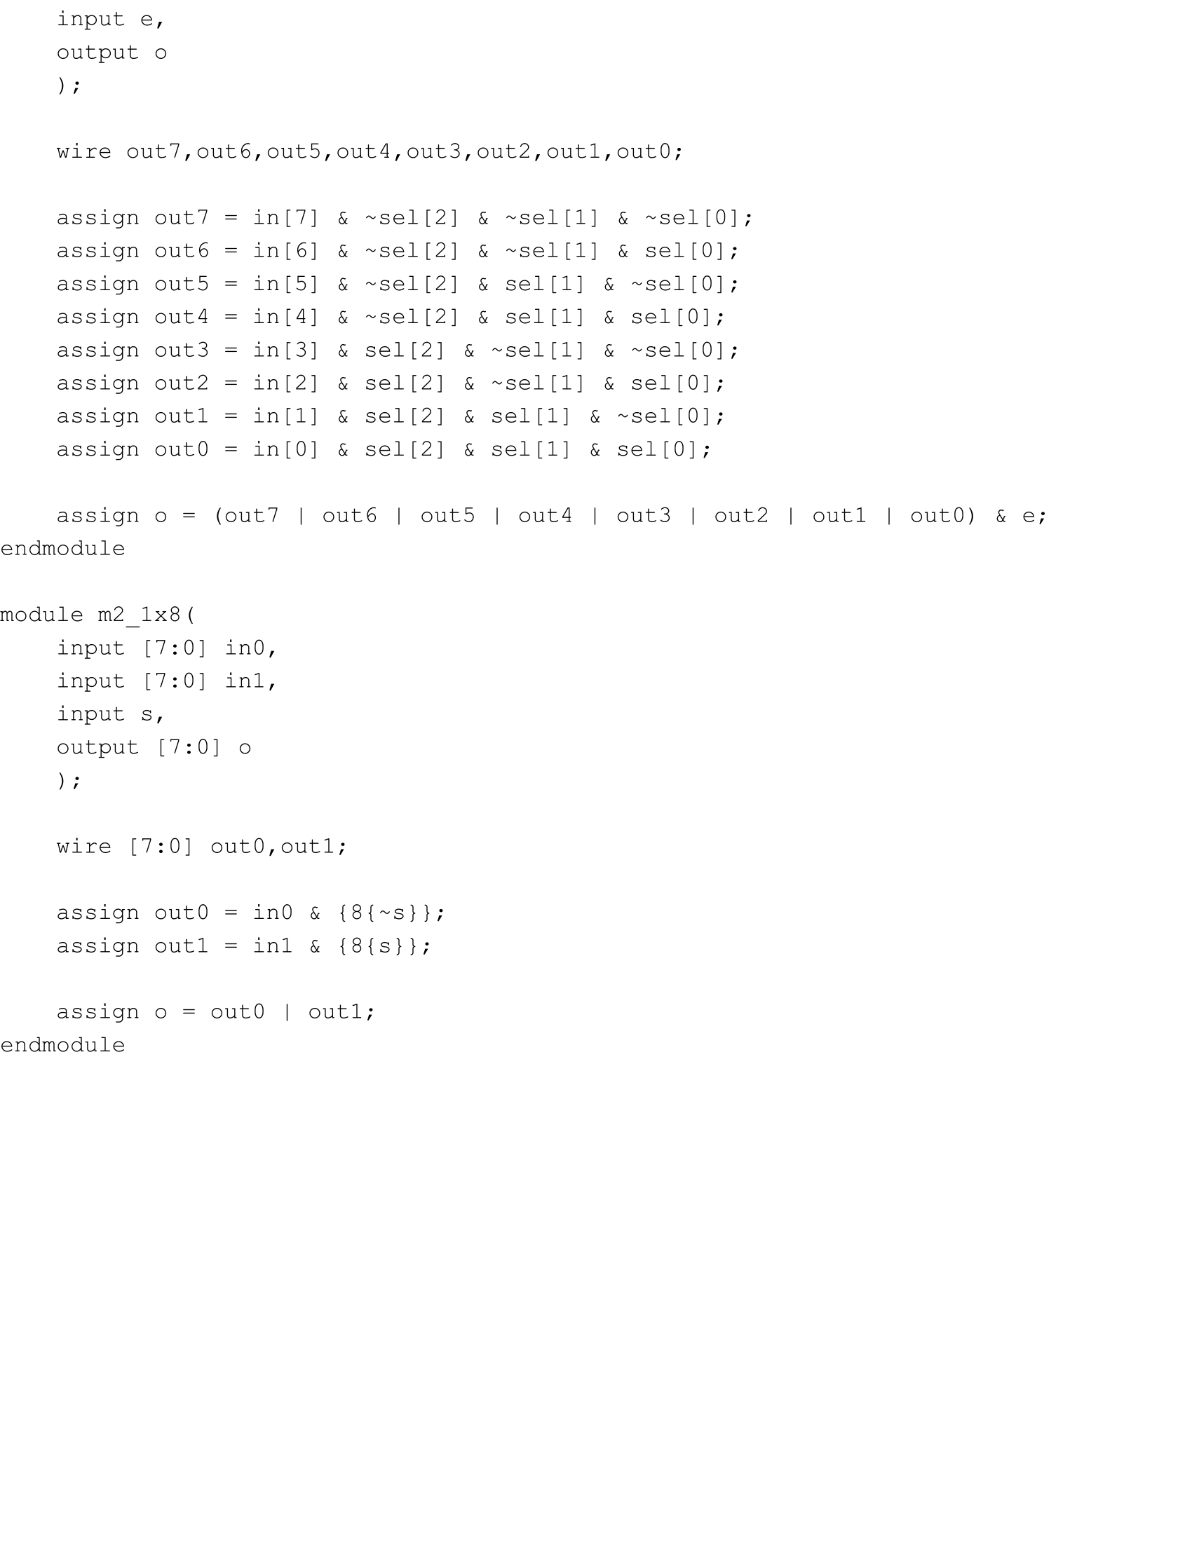

all_mux.v part 2

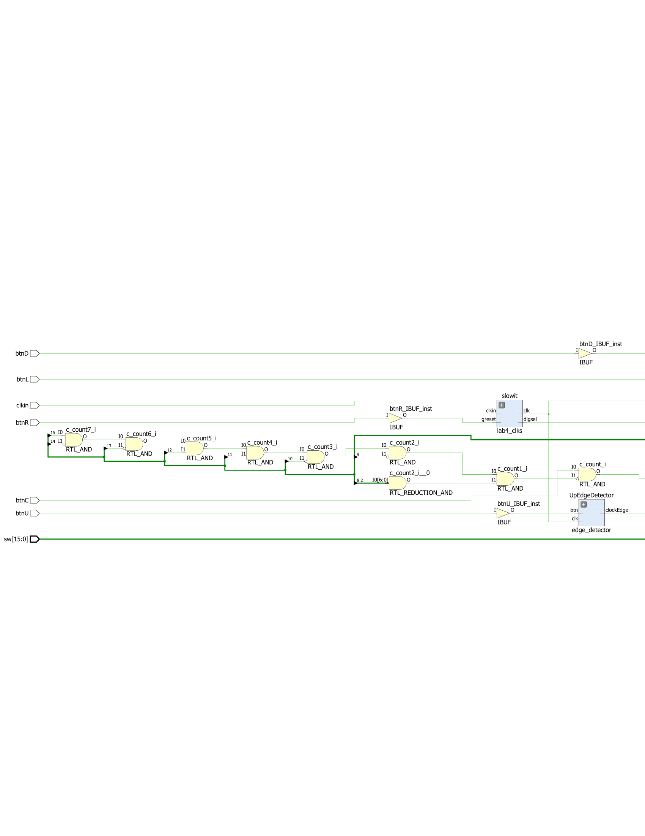

top_mod_schematic part 1

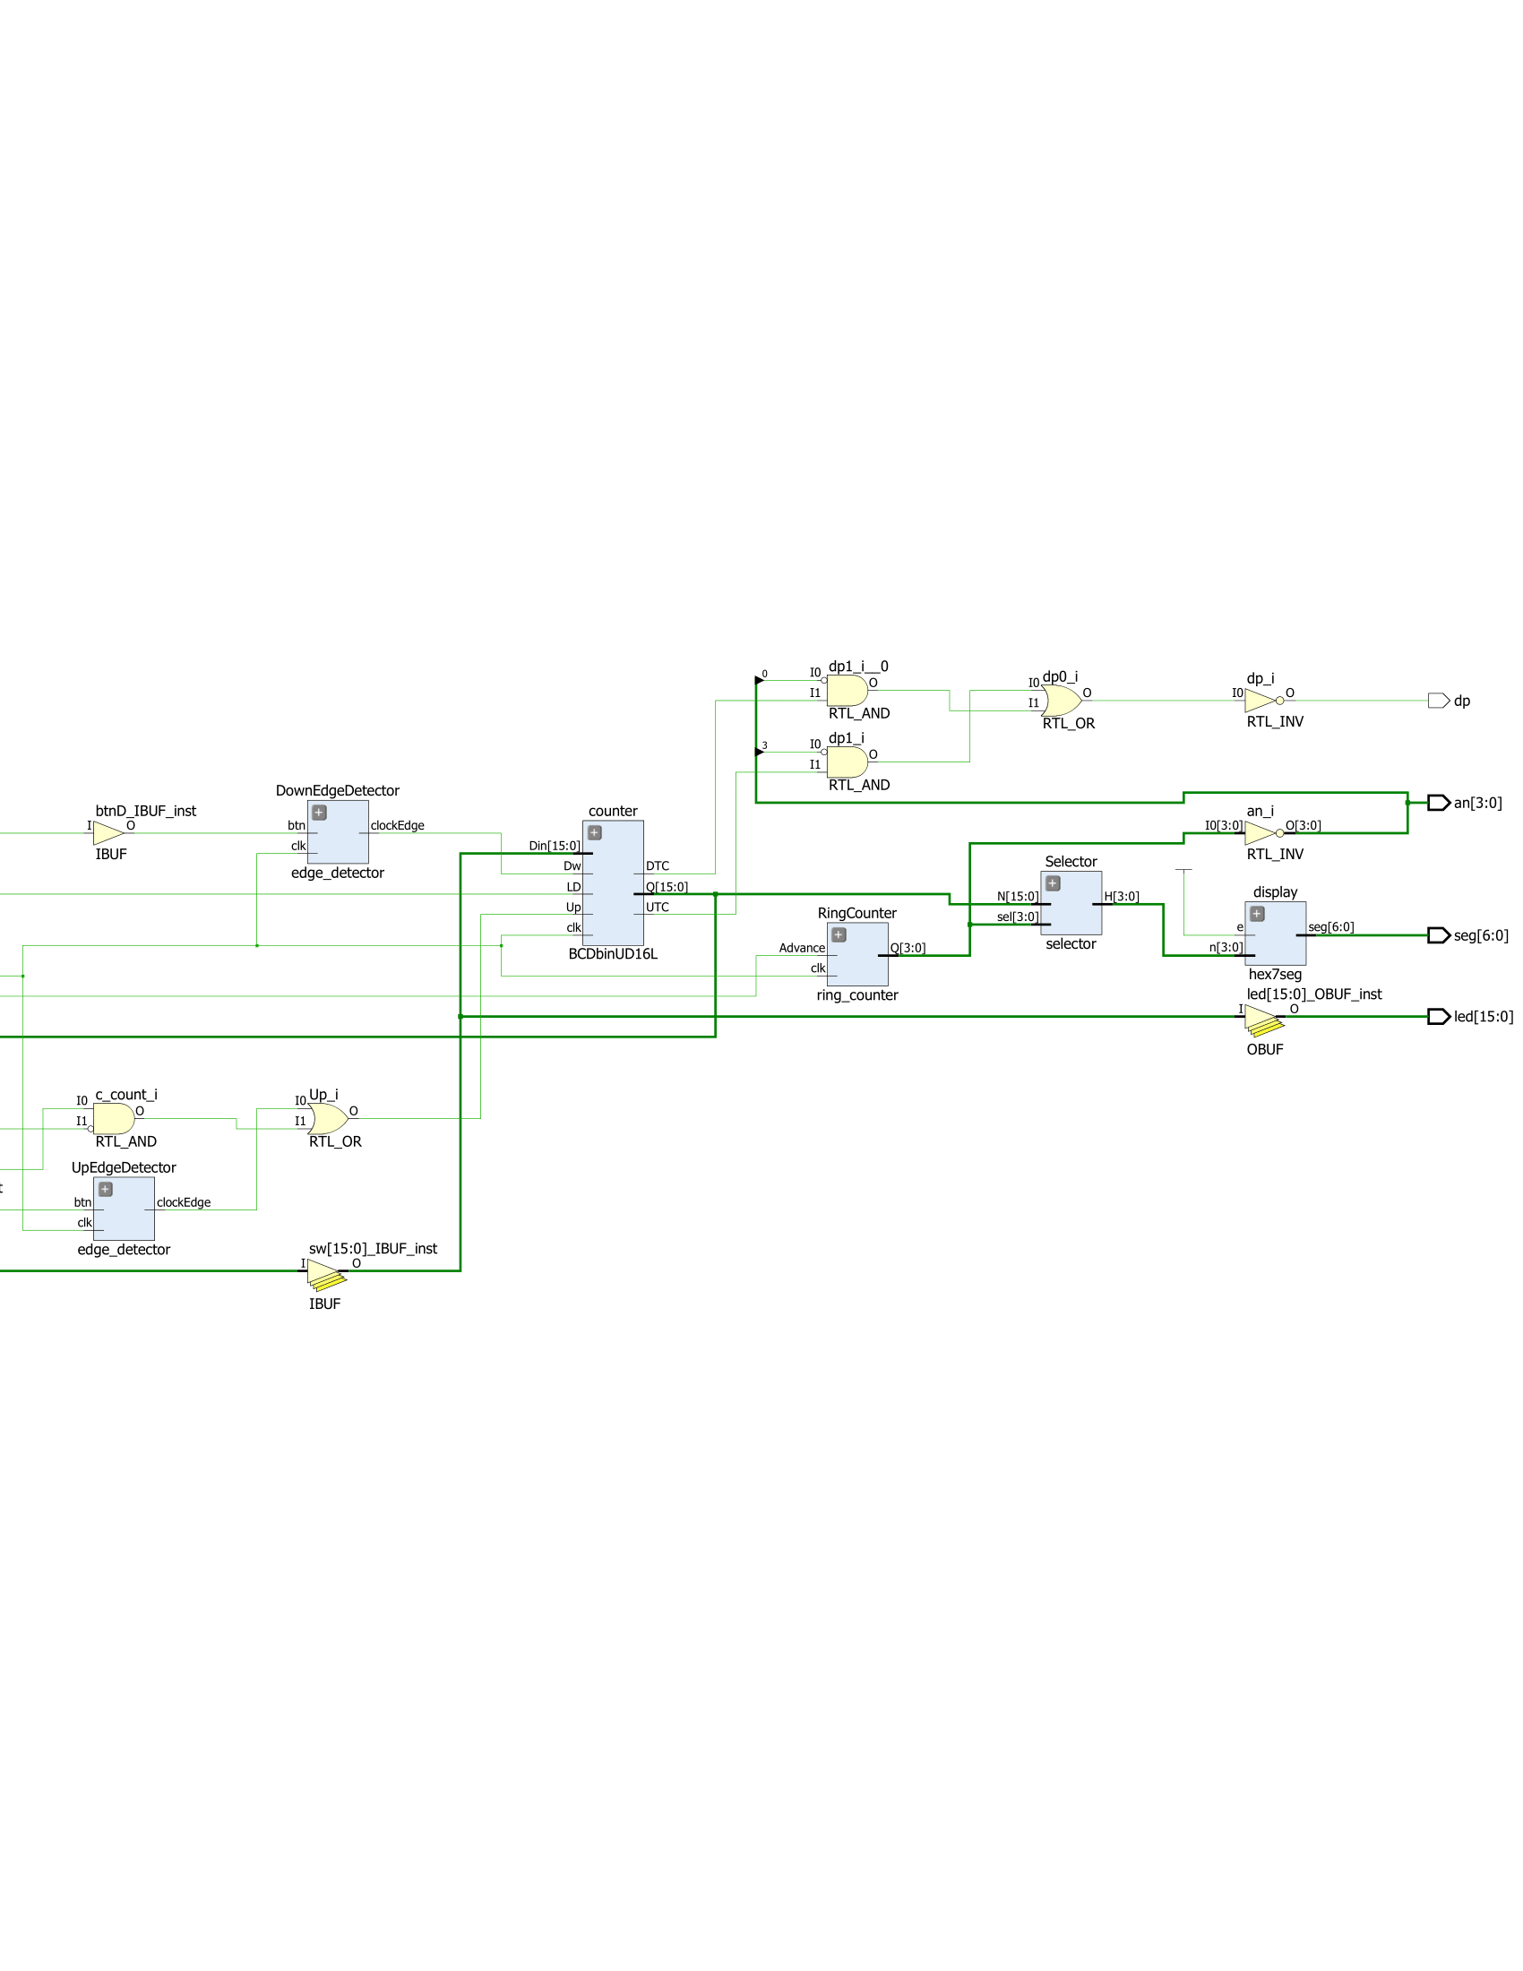

top_mod_schematic part 2



top_mod.v part 1

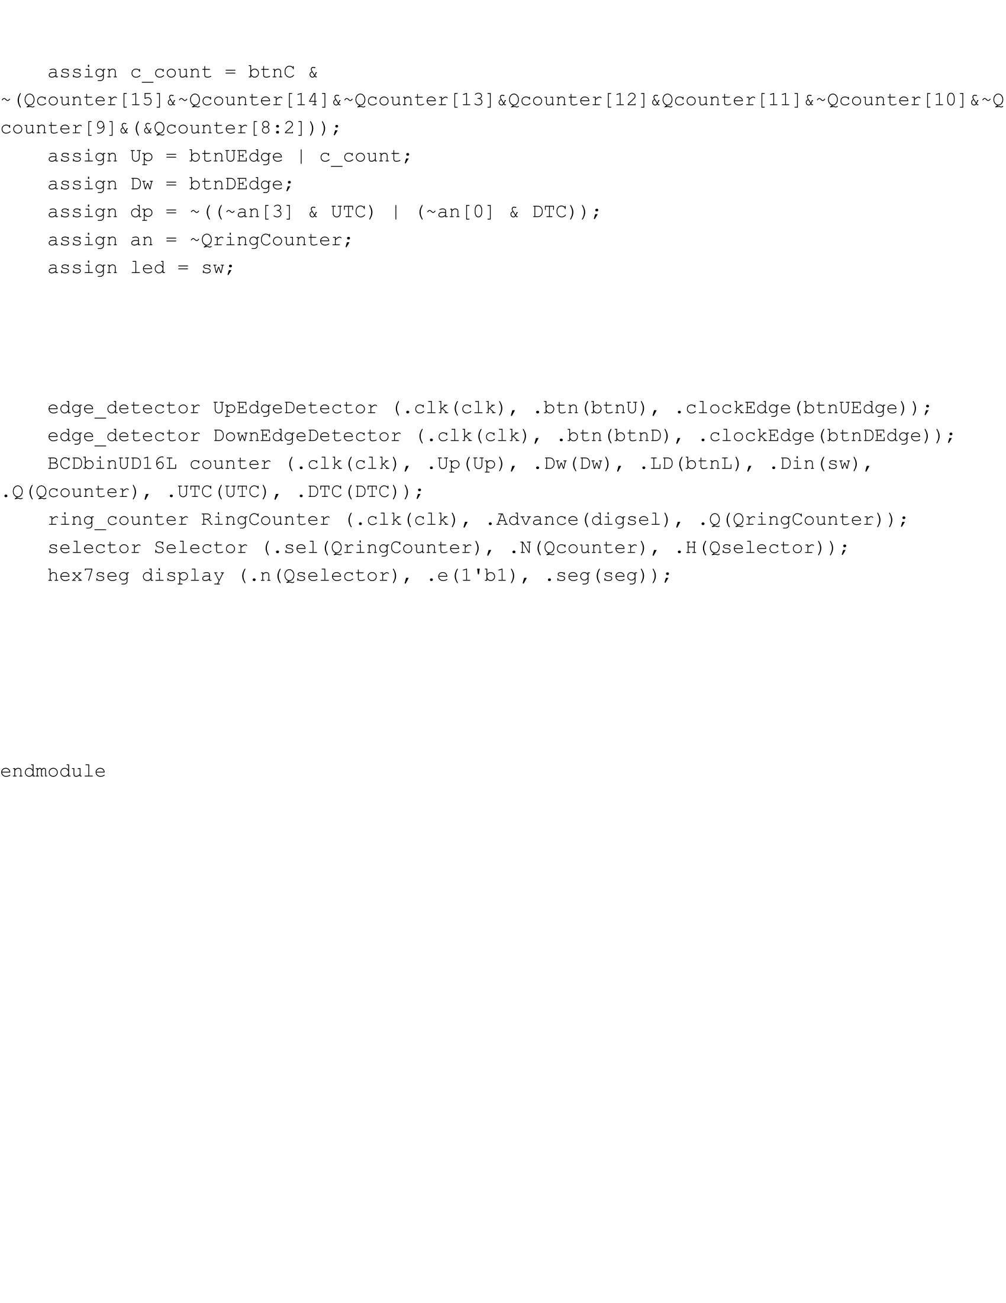

top_mod.v part 2



Waveform Viewer

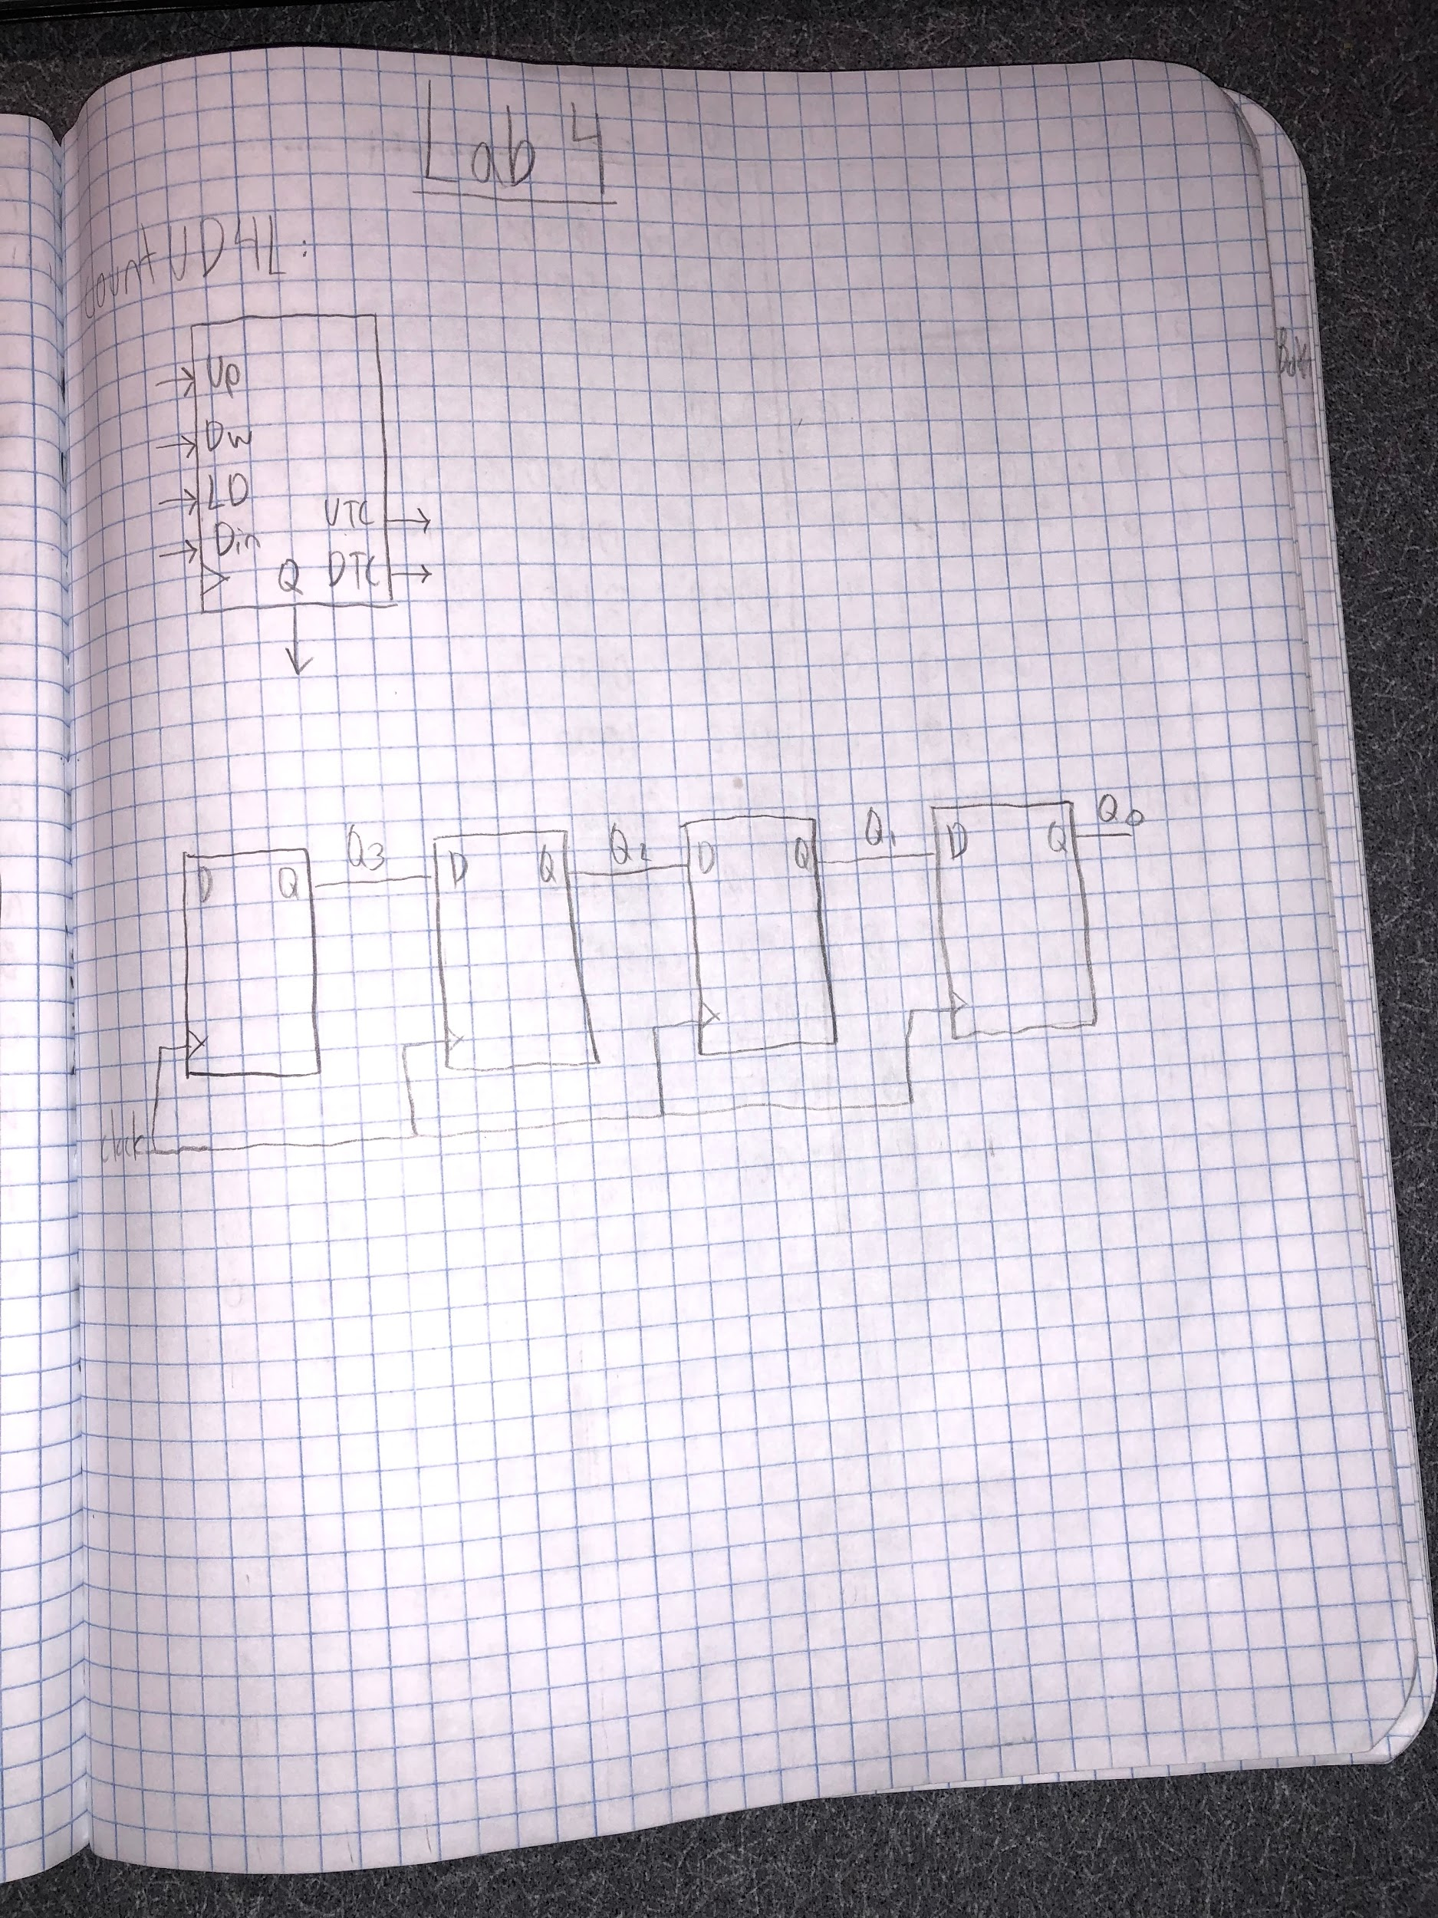

Lab Notebook Page 1

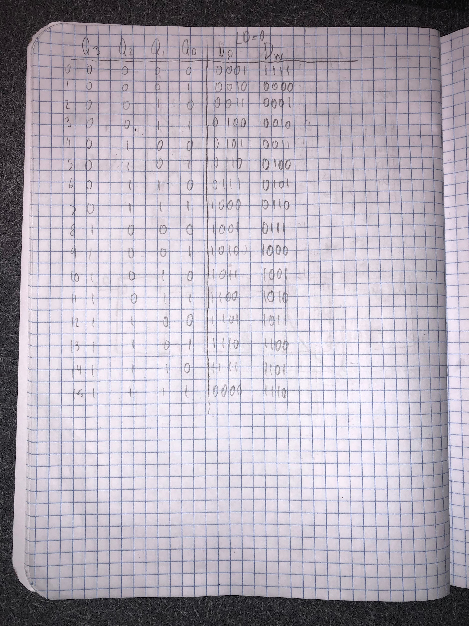

Lab Notebook Page 2

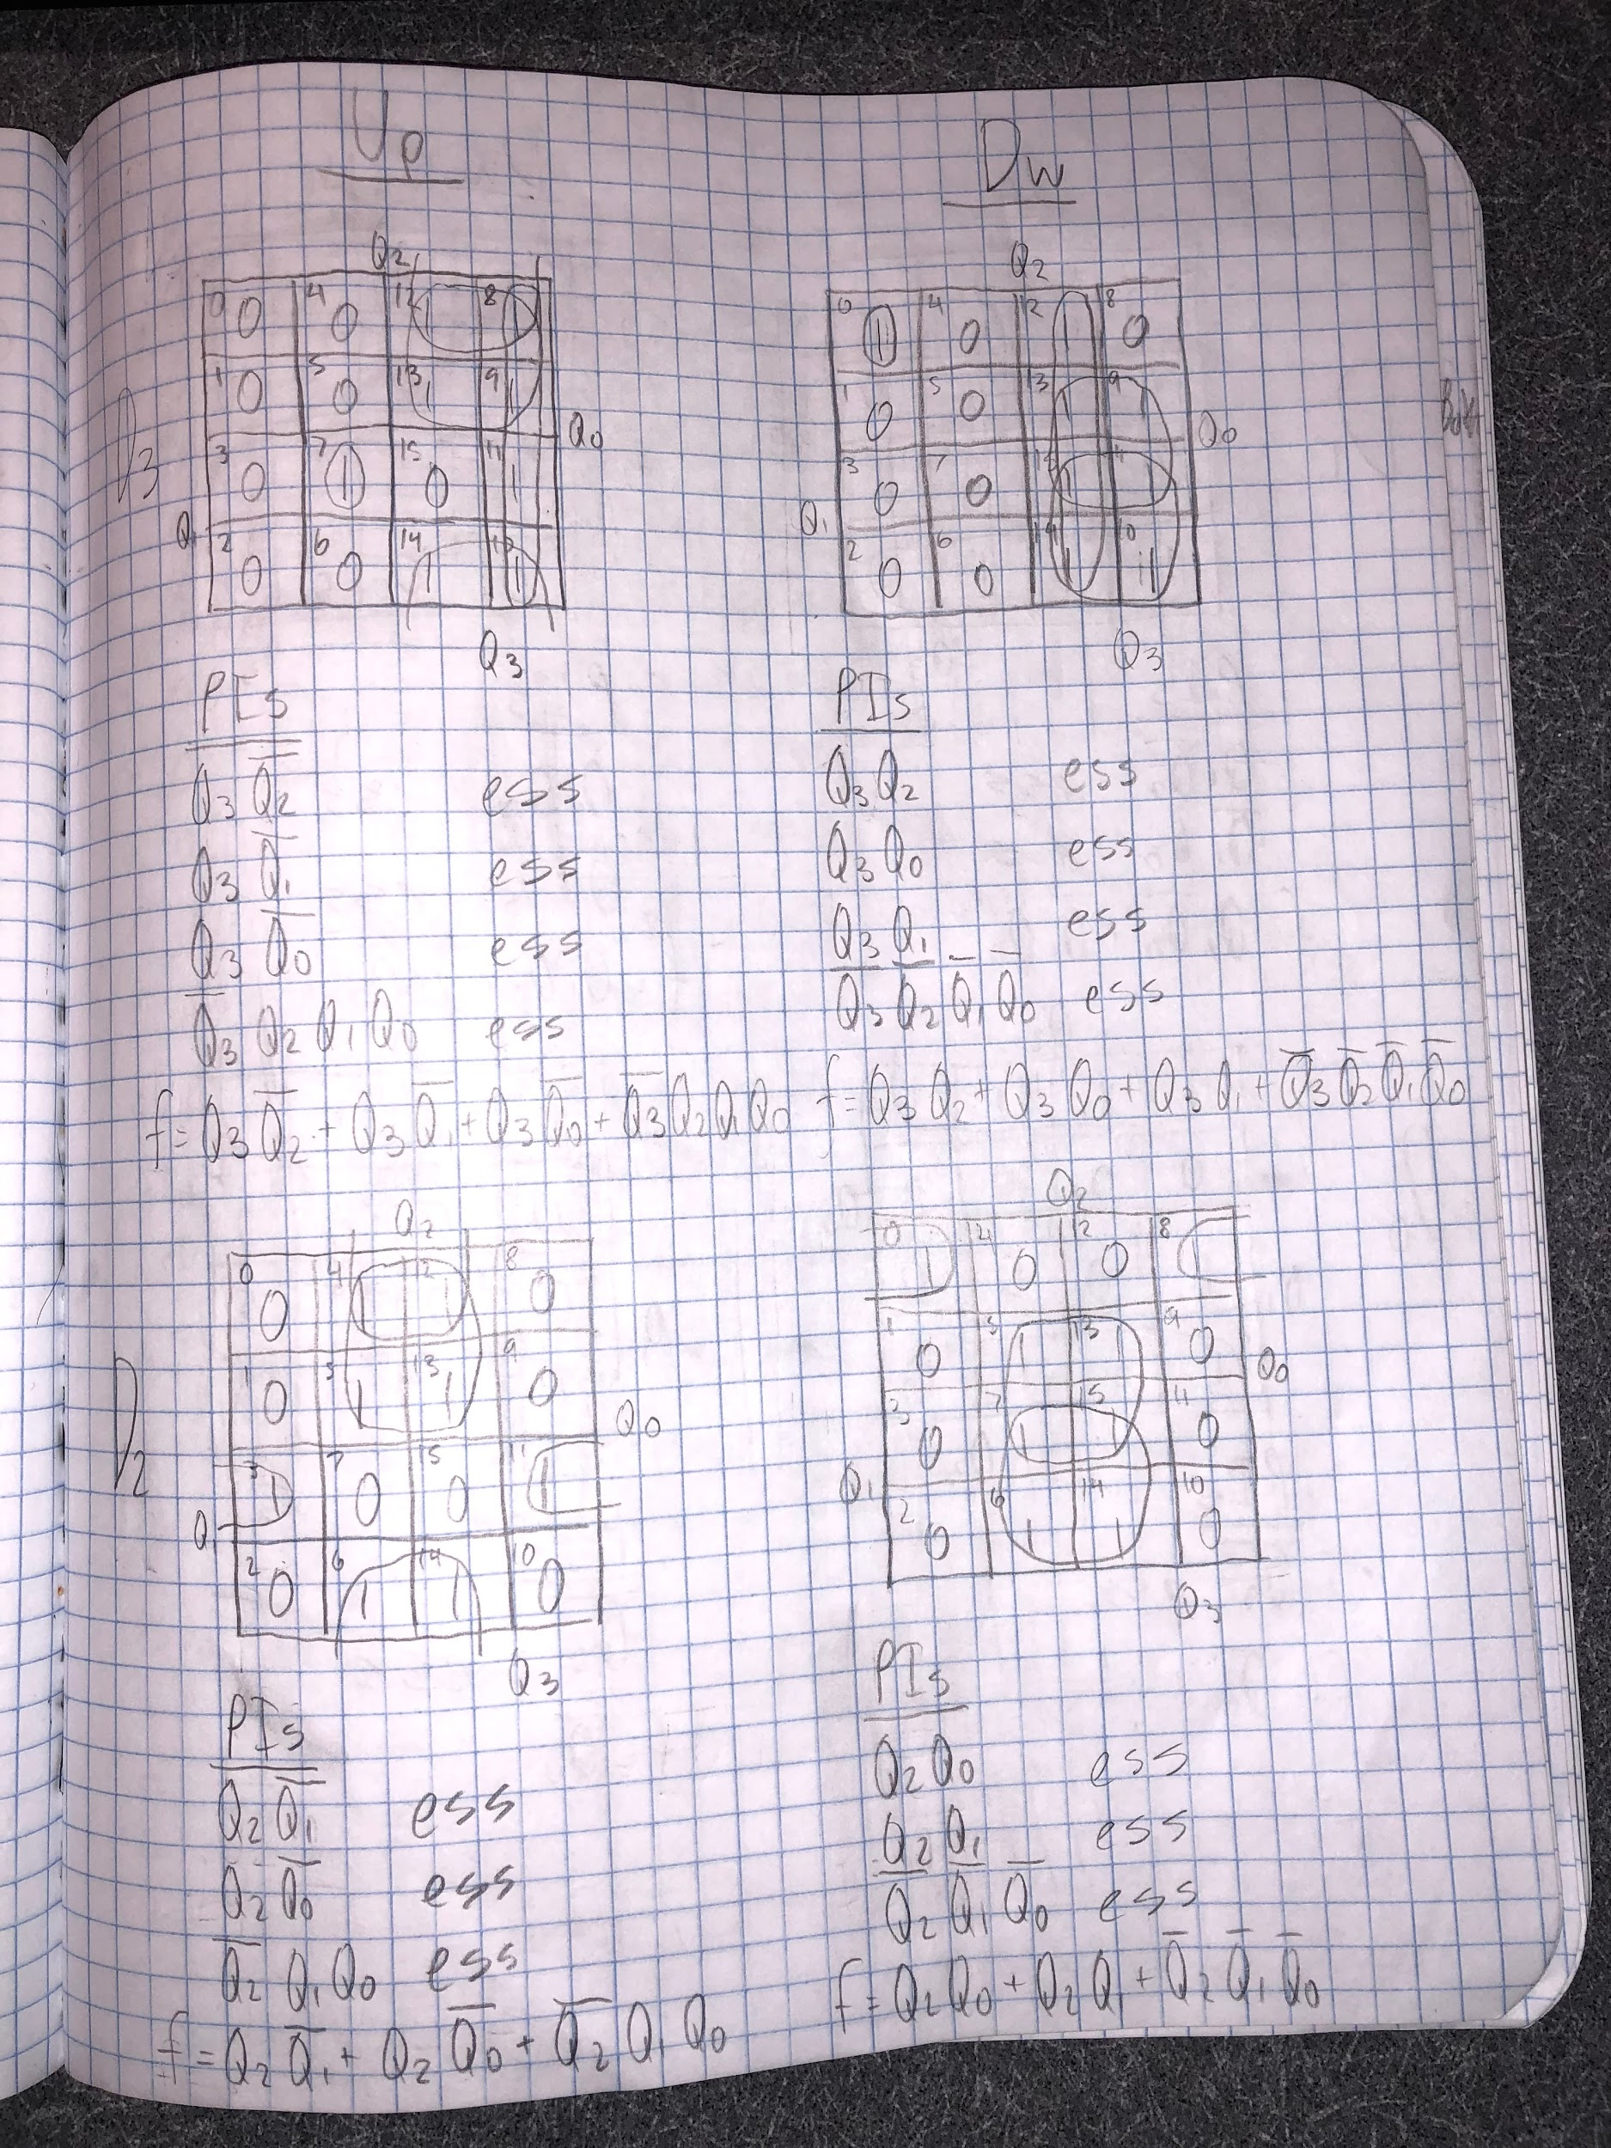

Lab Notebook Page 3

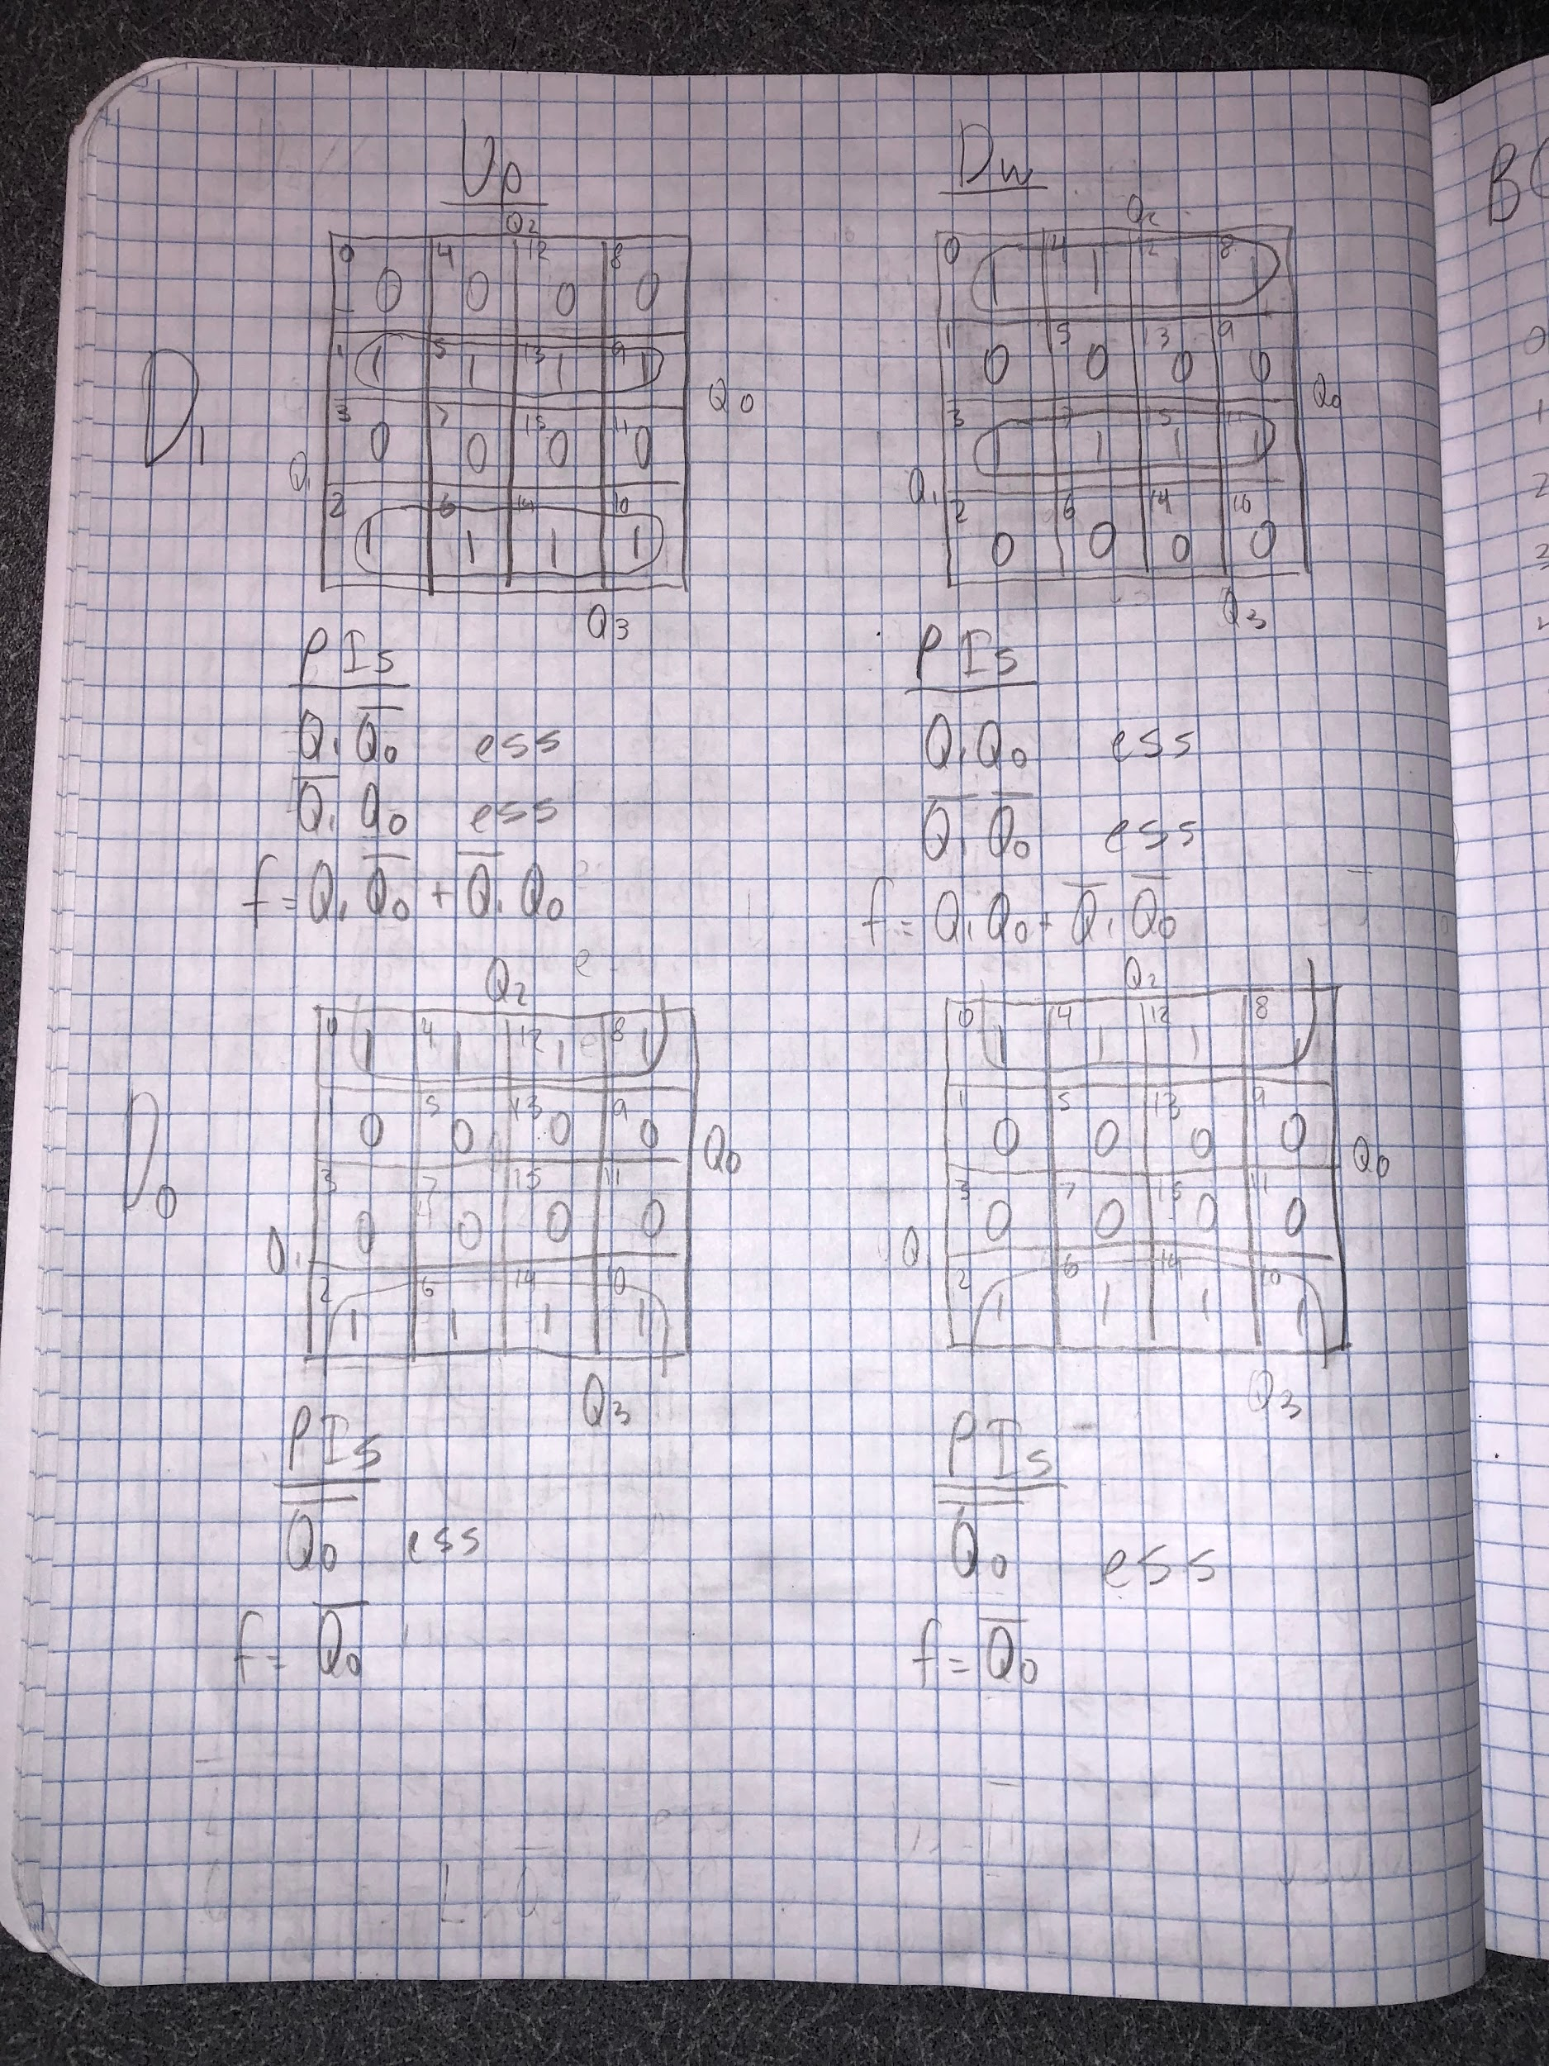

Lab Notebook Page 4

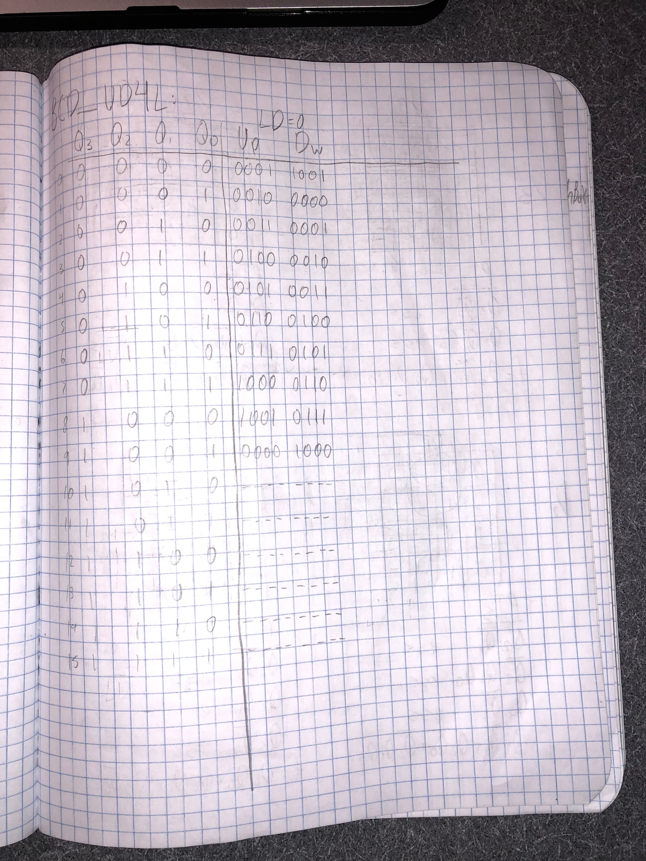

Lab Notebook Page 5

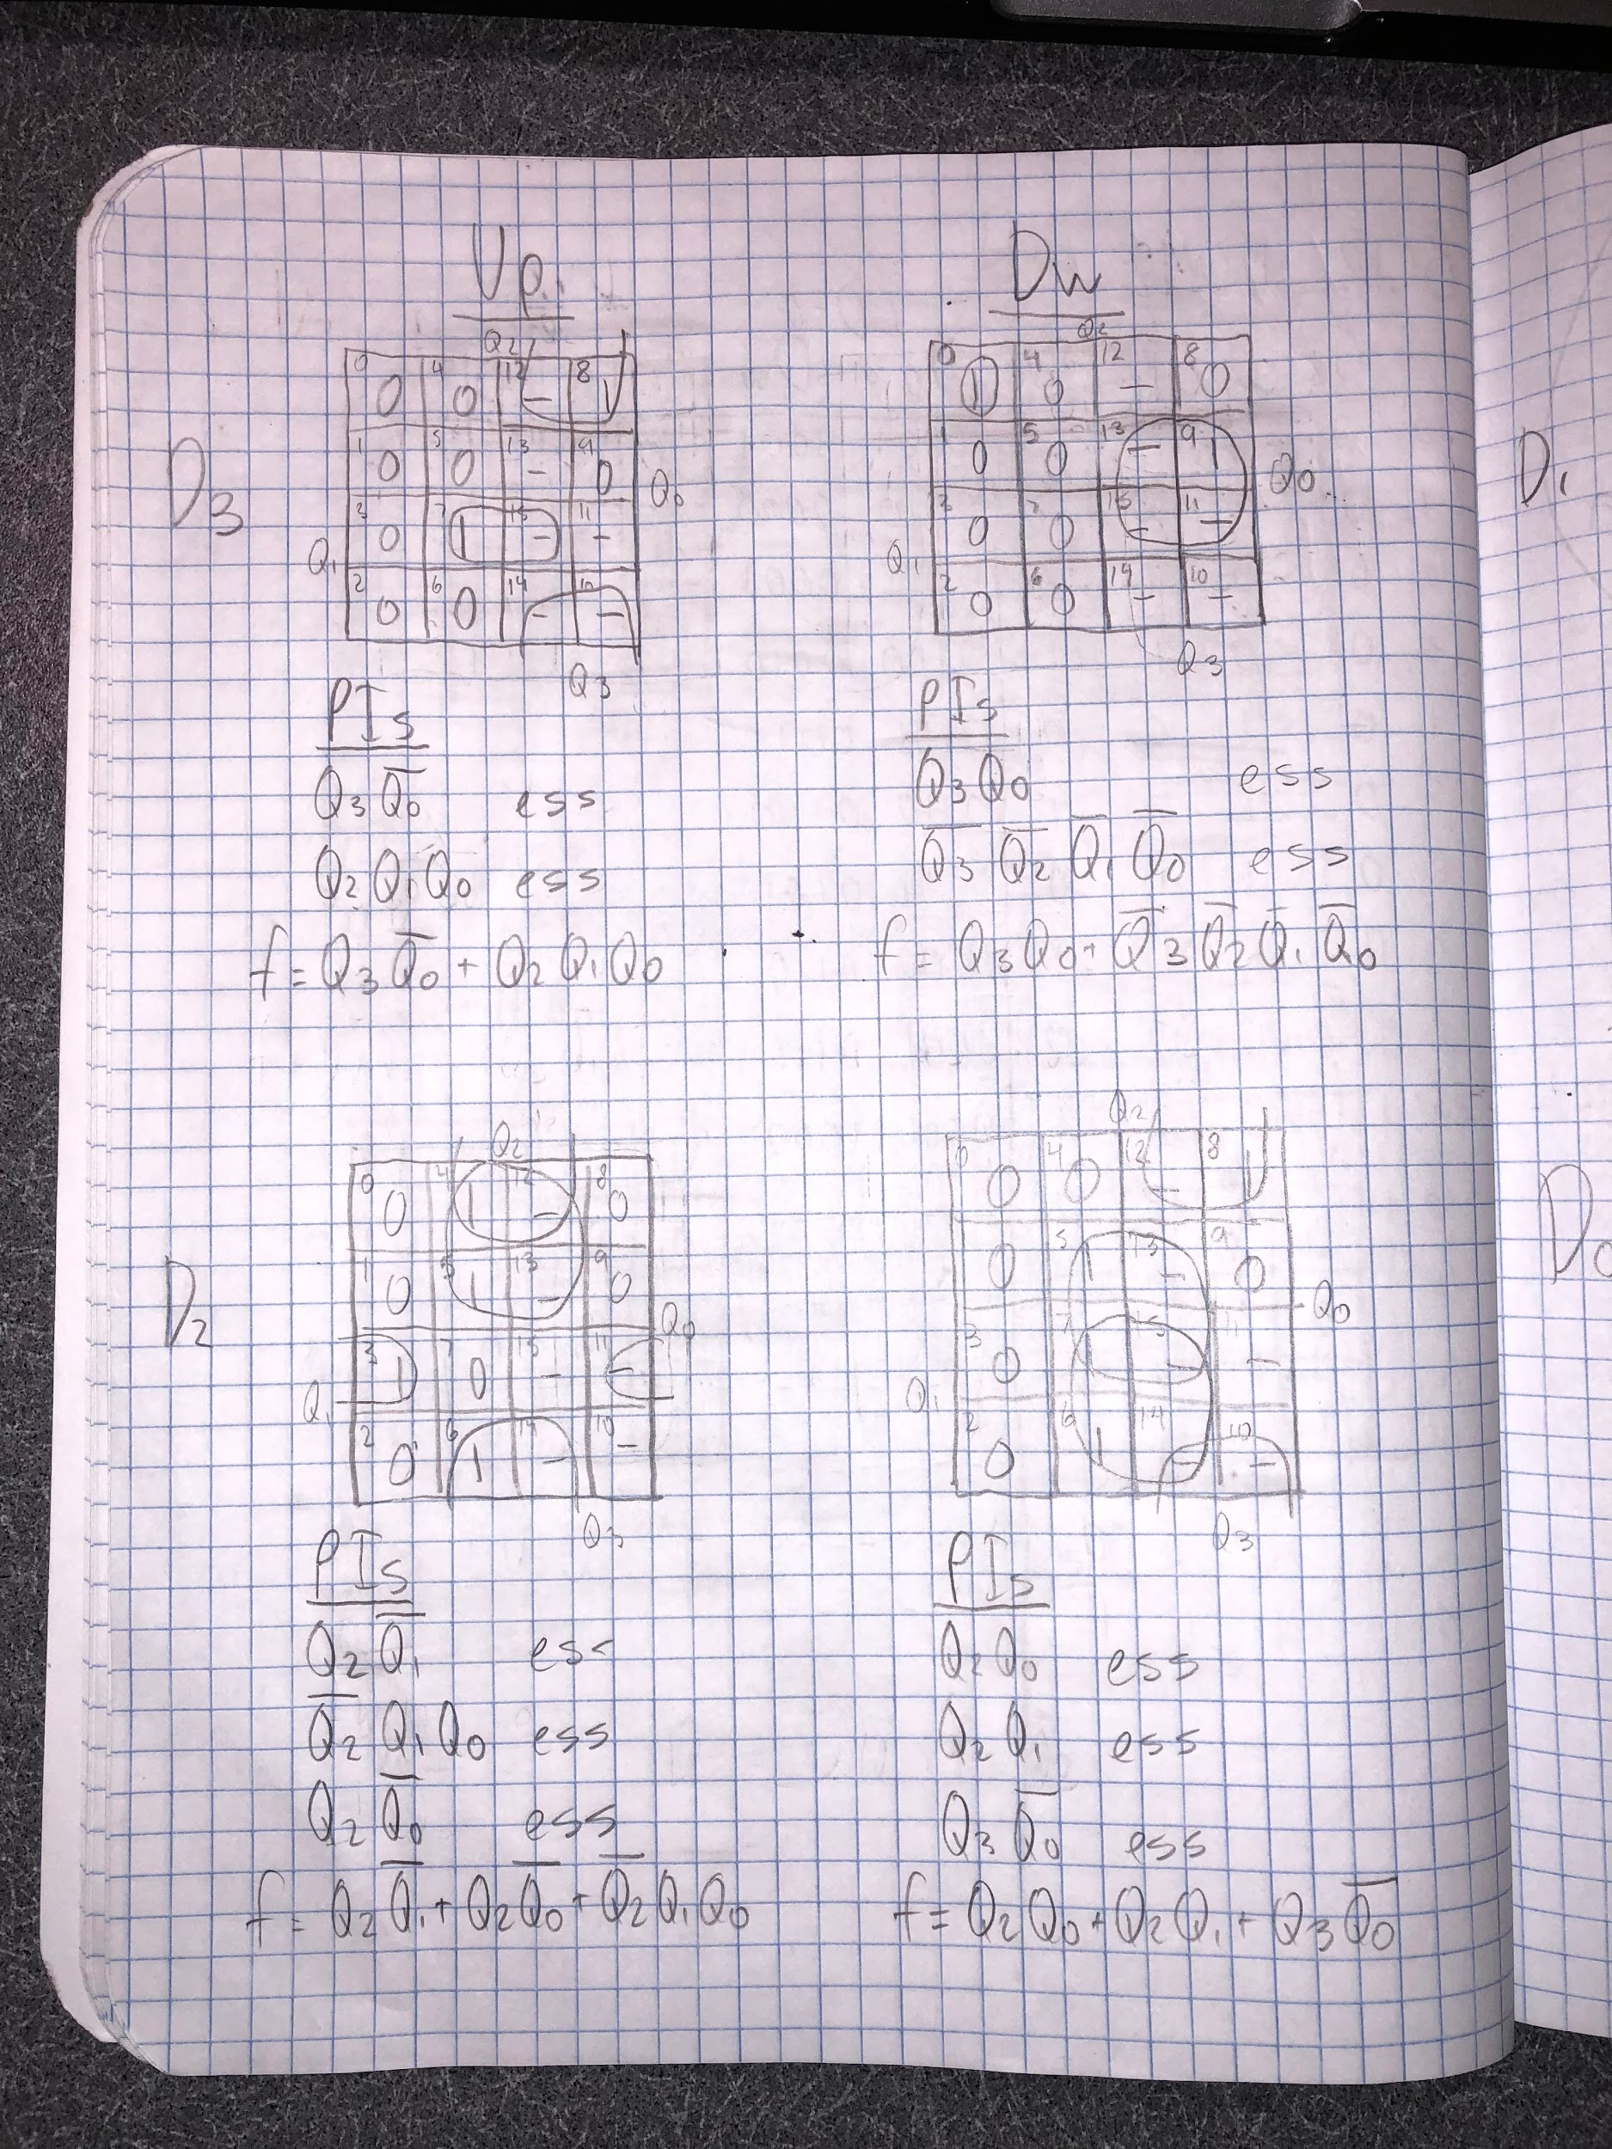

Lab Notebook Page 6

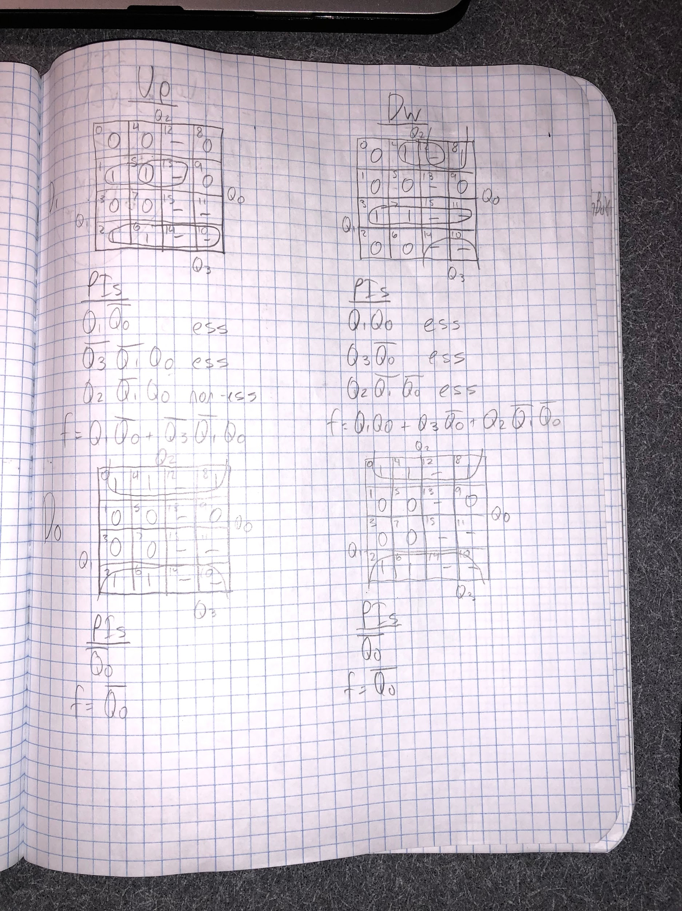

Lab Notebook Page 7

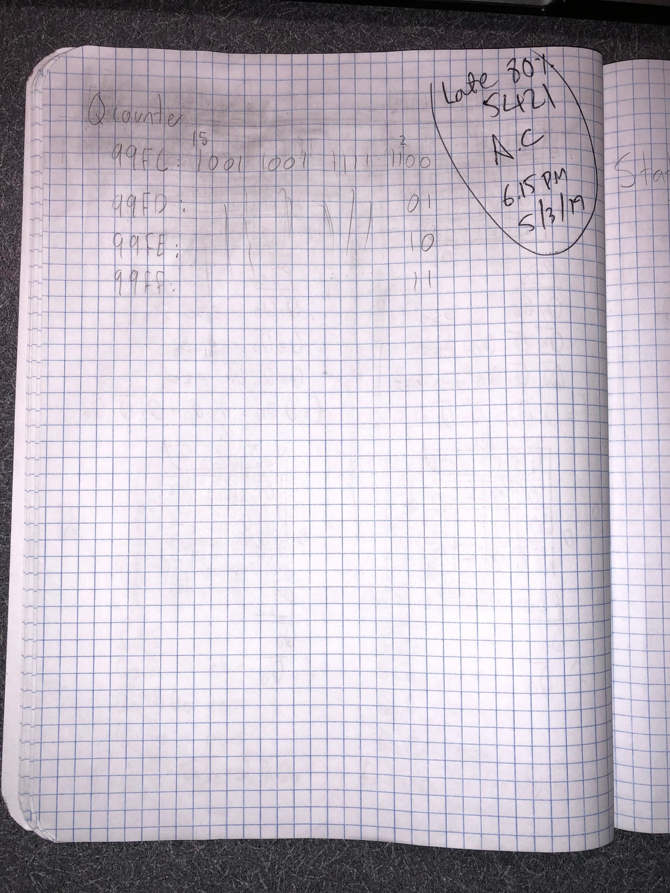

Lab Notebook Page 8